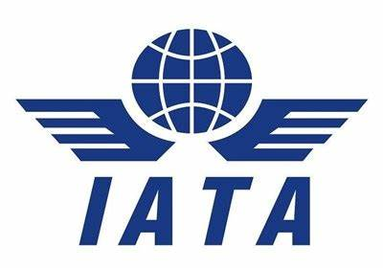

INTERNATIONAL AIR TRANSPORT ASSOCIATION

**A PROJECT ON BRITISH AIRWAYS AND DUBAI INTERNATIONAL AIRPORT**

SUMITTED TO: SUBMITTED BY:

DREAM SKY AVIATION SHIJIN SKARAH THOMAS

ADOOR

**INDEX**

**1.1 INTRODUCTION**

**British Airways** (**BA**) is the flag carrier of the United Kingdom. It is headquartered in London, England, near its main hub at Heathrow Airport.

The airline is the second largest UK-based carrier, based on fleet size and passengers carried, behind easyJet. In January 2011 BA merged with Iberia, creating the International Airlines Group (IAG), a holding company registered in Madrid, Spain. IAG is the world's third-largest airline group in terms of annual revenue and the second-largest in Europe. It is listed on the London Stock Exchange and in the FTSE 100 Index. British Airways is the first passenger airline to have generated more than US$1 billion on a single air route in a year (from 1 April 2017, to 31 March 2018, on the New York-JFK - London-Heathrow route).

BA was created in 1974 after a British Airways Board was established by the British government to manage the two nationalised airline corporations, British Overseas Airways Corporation and British European Airways, and two regional airlines, Cambrian Airways and Northeast Airlines. On 31 March 1974, all four companies were merged to form British Airways. However, it marked 2019 as its centenary based on predecessor companies. After almost 13 years as a state company, BA was privatised in February 1987 as part of a wider privatisation plan by the Conservative government. The carrier expanded with the acquisition of British Caledonian in 1987, Dan-Air in 1992, and British Midland International in 2012.

It is a founding member of the Oneworld airline alliance, along with American Airlines, the now-defunct Canadian Airlines, Cathay Pacific, and Qantas. The alliance has since grown to become the third-largest, after SkyTeam and Star Alliance.

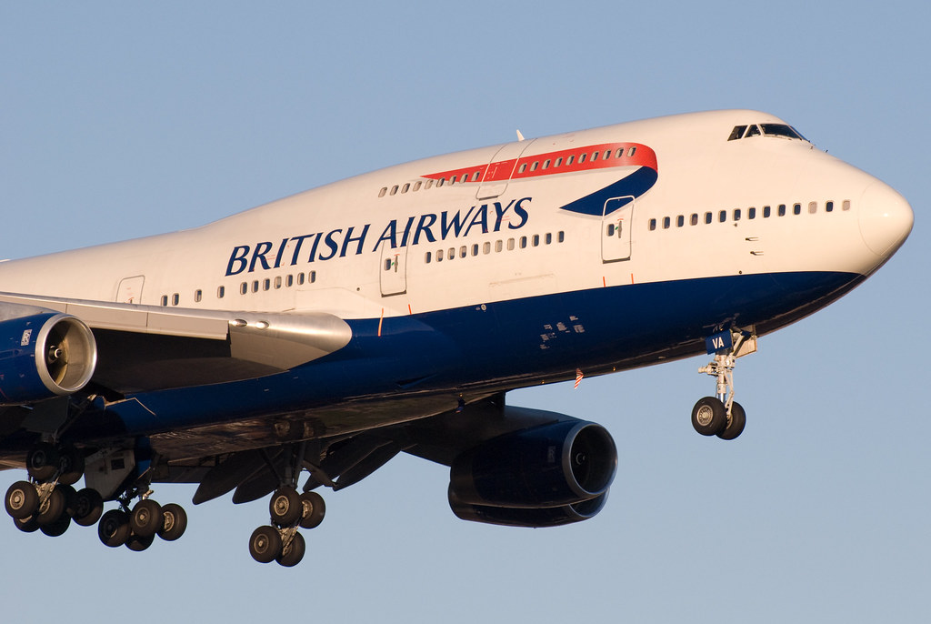

**1.2 HISTORY OF BRITISH AIRWAYS**

Proposals to establish a joint British airline, combining the assets of the British Overseas Airways Corporation (BOAC) and British European Airways (BEA), were first raised in 1953 as a result of difficulties in attempts by BOAC and BEA to negotiate air rights through the British colony of Cyprus. Increasingly BOAC was protesting that BEA was using its subsidiary Cyprus Airways to circumvent an agreement that BEA would not fly routes further east than Cyprus, particularly to the increasingly important oil regions in the Middle East. The chairman of BOAC, Miles Thomas, was in favour of a merger as a potential solution to this disagreement and had backing for the idea from the Chancellor of the Exchequer at the time, Rab Butler. However, opposition from the Treasury blocked the proposal.

Consequently, it was only following the recommendations of the 1969 Edwards Report that a new British Airways Board, managing both BEA and BOAC, and the two regional British airlines Cambrian Airways based at Cardiff, and Northeast Airlines based at Newcastle upon Tyne, was constituted on 1 April 1972. Although each airline's branding was maintained initially, two years later the British Airways Board unified its branding, effectively establishing British Airways as an airline on 31 March 1974.

Following two years of fierce competition with British Caledonian, the second-largest airline in the United Kingdom at the time, the Government changed its aviation policy in 1976 so that the two carriers would no longer compete on long-haul routes.

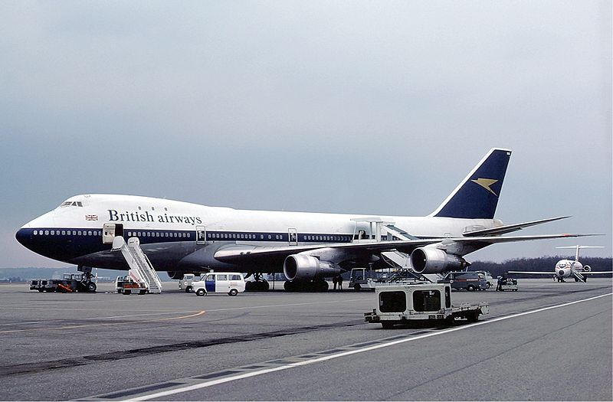

A Boeing 747-100 in BOAC-British Airways transition livery (1976)

British Airways and Air France operated the supersonic airliner Aerospatiale-BAC Concorde, and the world's first supersonic passenger service flew in January 1976 from Heathrow Airport to Bahrain International Airport.Services to the US began on 24 May 1976 with a flight to Washington Dulles airport, and flights to New York JFK airport followed on 22 September 1977. Service to Singapore was established in co-operation with Singapore Airlines as a continuation of the flight to Bahrain. Following the Air France Concorde crash in Paris and a slump in air travel following the 11 September attacks in New York in 2001, it was decided to cease Concorde operations in 2003 after 27 years of service. The final commercial Concorde flight was BA002 from New York-JFK to London-Heathrow on 24 October 2003.

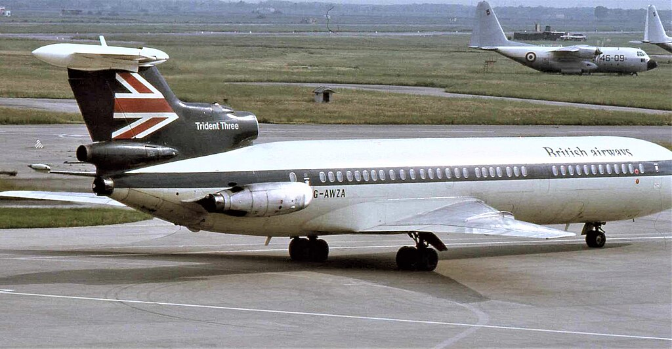

A British Airways Hawker Siddeley Trident in its transitional scheme with BEA livery but with British Airways titles.

In 1981 the airline was instructed to prepare for privatisation by the Conservative Thatcher government. Sir John King, later Lord King, was appointed chairman, charged with bringing the airline back into profitability. While many other large airlines struggled, King was credited with transforming British Airways into one of the most profitable air carriers in the world. The flag carrier was privatised and was floated on the London Stock Exchange in February 1987. British Airways effected the takeover of the UK's "second" airline, British Caledonian, in July of that same year.

The formation of Richard Branson's Virgin Atlantic in 1984 created a competitor for BA. The intense rivalry between British Airways and Virgin Atlantic culminated in the former being sued for libel in 1993, arising from claims and counterclaims over a "dirty tricks" campaign against Virgin. This campaign included allegations of poaching Virgin Atlantic customers, tampering with private files belonging to Virgin, and undermining Virgin's reputation in the city. As a result of the case BA management apologised "unreservedly", and the company agreed to pay £110,000 in damages to Virgin, £500,000 to Branson personally and £3 million legal costs. Lord King stepped down as chairman in 1993 and was replaced by his deputy, Colin Marshall, while Bob Ayling took over as CEO. Virgin filed a separate action in the US that same year regarding BA's domination of the trans-Atlantic routes, but it was thrown out in 1999.

In 1992 British Airways expanded through the acquisition of the financially troubled Dan-Air, giving BA a much larger presence at Gatwick Airport. British Asia Airways, a subsidiary based in Taiwan, was formed in March 1993 to operate between London and Taipei. That same month BA purchased a 25% stake in the Australian airline Qantas and, with the acquisition of Brymon Airways in May, formed British Airways Citiexpress (later BA Connect). In September 1998, British Airways, along with American Airlines, Cathay Pacific, Qantas, and Canadian Airlines, formed the Oneworld airline alliance. Oneworld began operations on 1 February 1999, and is the third-largest airline alliance in the world, behind SkyTeam and Star Alliance.

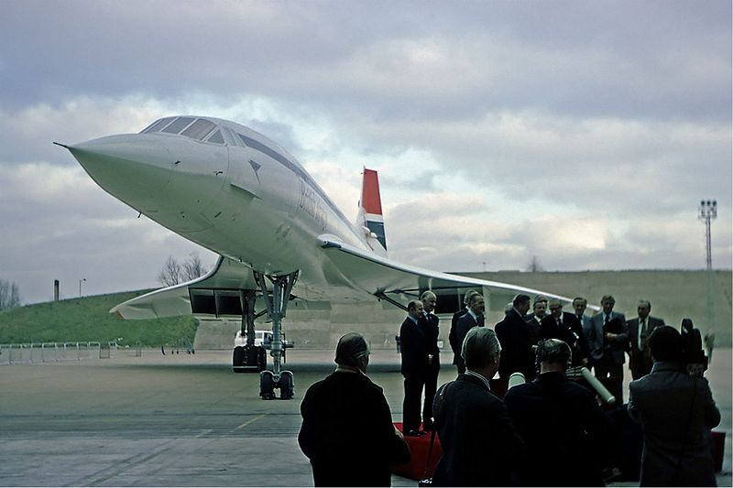

British Airways' first Concorde at Heathrow Airport, on 15 January 1976

Bob Ayling's leadership led to a cost savings of £750m and the establishment of a budget airline, Go, in 1998.The next year, however, British Airways reported an 84% drop in profits in its first quarter alone, its worst in seven years. In March 2000, Ayling was removed from his position and British Airways announced Rod Eddington as his successor. That year, British Airways and KLM conducted talks on a potential merger, reaching a decision in July to file an official merger plan with the European Commission.The plan fell through in September 2000.British Asia Airways ceased operations in 2001 after BA suspended flights to Taipei. Go was sold to its management and the private equity firm 3i in June 2001. Eddington would make further workforce cuts due to reduced demand following 11 September attacks in 2001, and BA sold its stake in Qantas in September 2004. In 2005 Willie Walsh, managing director of Aer Lingus and a former pilot, became the chief executive officer of British Airways.BA unveiled its new subsidiary OpenSkies in January 2008, taking advantage of the liberalisation of transatlantic traffic rights between Europe and the United States. OpenSkies flies non-stop from Paris to New York's JFK and Newark airports.

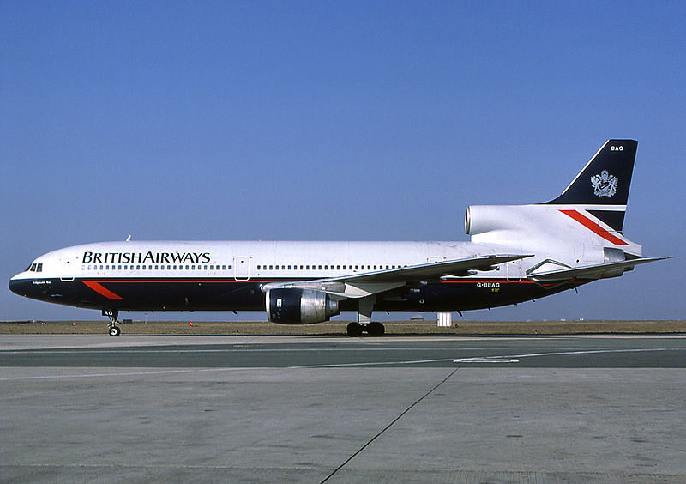

A British Airways Lockheed TriStar in Landor livery

In July 2008, British Airways announced a merger plan with Iberia, another flag carrier airline in the Oneworld alliance, wherein each airline would retain its original brand. The agreement was confirmed in April 2010, and in July the European Commission and US Department of Transport permitted the merger and began to co-ordinate transatlantic routes with American Airlines. On 6 October 2010 the alliance between British Airways, American Airlines and Iberia formally began operations. The alliance generates an estimated £230 million in annual cost-saving for BA, in addition to the £330 million which would be saved by the merger with Iberia.This merger was finalised on 21 January 2011, resulting in the International Airlines Group (IAG), the world's third-largest airline in terms of annual revenue and the second-largest airline group in Europe. Prior to merging, British Airways owned a 13.5% stake in Iberia, and thus received ownership of 55% of the combined International Airlines Group; Iberia's other shareholders received the remaining 45%. As a part of the merger, British Airways ceased trading independently on the London Stock Exchange after 23 years as a constituent of the FTSE 100 Index.

In September 2010 Willie Walsh, now CEO of IAG, announced that the group was considering acquiring other airlines and had drawn up a shortlist of twelve possible acquisitions. In November 2011 IAG announced an agreement in principle to purchase British Midland International from Lufthansa. A contract to purchase the airline was agreed the next month, and the sale was completed for £172.5 million on 30 March 2012. The airline established a new subsidiary based at London City Airport Operating Airbus A318s.

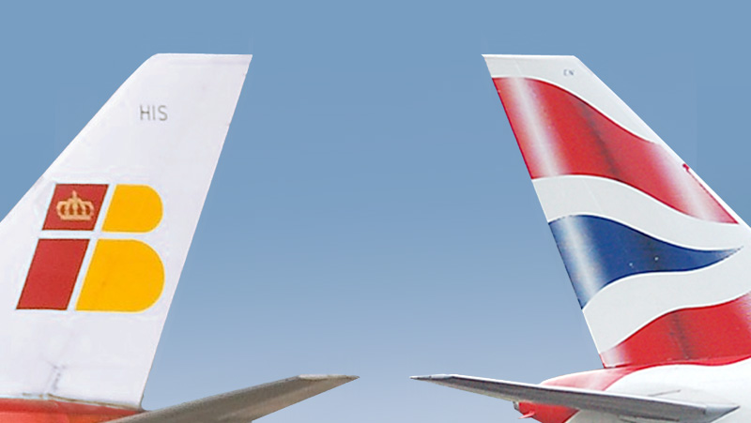

British Airways was the official airline partner of the London 2012 Olympic Games. On 18 May 2012 it flew the Olympic flame from Athens International Airport to RNAS Culdrose while carrying various dignitaries, including Lord Sebastian Coe, Princess Anne, the Olympics minister Hugh Robertson and the London Mayor Boris Johnson, along with the footballer David Beckham.

On 27 May 2017, British Airways suffered a computer power failure. All flights were cancelled and thousands of passengers were affected. By the following day, the company had not succeeded in re-establishing the normal function of its computer systems. When asked by reporters for more information on the ongoing problems, British Airways stated "The root cause was a power supply issue which our affected our IT systems - we continue to investigate this" and declined to comment further. Willie Walsh later attributed the crash to an electrical engineer disconnecting the UPS and said there would be an independent investigation.

Amidst the decline in the value of Iranian currency due to the reintroduction of US sanctions on Iran, BA announced that the Iranian route is "not commercially viable". As a result, BA decided to stop its services in Iran, effective 22 September 2018.

In 2018, British Airways partnered with British tailor and designer Ozwald Boateng to redesign the company's historic uniforms, in honour of its approaching centenary, creating a new look for BA, while adhering to its traditional style. The new collection "A British Original" was launched in 2023. This design initiative also included English bone china manufactured by William Edwards and cutlery by Studio William for the company's first-class service.

In 2019, as part of the celebrations of a centenary of airline operations in the United Kingdom, British Airways announced that four aircraft would receive retro liveries. The first of these is a Boeing 747-400 (G-BYGC), which was repainted into the former BOAC livery, which it retained until its retirement. Two more Boeing 747-400s were repainted with former British Airways liveries. One wore the "Landor" livery until its retirement in 2020 (G-BNLY), the other (G-CIVB), wore the original "Union Jack" livery until its retirement in 2020 also. An Airbus A319 was repainted into British European Airways livery, which is still flying as G-EUPJ.

On 28 April 2020, the company set out plans to make up to 12,000 staff redundant because of the global collapse of air traffic due to the COVID-19 pandemic and that it may not reopen its operations at Gatwick airport. In July 2020, British Airways announced the immediate retirement of its entire 747-400 fleet, having originally intended to phase out the remaining 747s in 2024. The airline stated that its decision to bring forward the date was in part due to the downturn in air travel following the COVID-19 pandemic and to focus on incorporating more modern and fuel-efficient aircraft such as the Airbus A350 and Boeing 787. At the same time, British Airways also announced its intention to eliminate carbon emissions by 2050. On 28 July 2020, the company's cabin crew union issued an "industrial action" warning in order to prevent the 12,000 job cuts and pay cuts.

On 12 October 2020, it was announced that Sean Doyle, CEO of Aer Lingus (also part of the IAG airline group) would succeed Álex Cruz as CEO.

**1.3 CORPORATE AFFAIRS**

* **Operations:**

### British Airways is the largest airline based in the United Kingdom in terms of fleet size, international flights, and international destinations and was, until 2008, the largest airline by passenger numbers. The airline carried 34.6 million passengers in 2008, but, rival carrier easyJet transported 44.5 million passengers that year, passing British Airways for the first time. British Airways holds a United Kingdom Civil Aviation Authority Type a Operating Licence, it is permitted to carry passengers, cargo, and mail on aircraft with 20 or more seats.

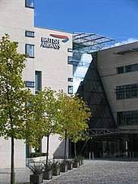

Waterside, the head office building of British Airways.

The airlines' head office, Waterside, stands in Harmondsworth, a village that is near Heathrow Airport. Waterside was completed in June 1998 to replace British Airways' previous head office, Speedbird House, located in Technical Block C on the grounds of Heathrow.

British Airways' main base is at Heathrow Airport, but it also has a major presence at Gatwick Airport. It also has a base at London City Airport, where its subsidiary BA Cityflyer is the largest operator. BA had previously operated a significant hub at Manchester Airport. Manchester to New York (JFK) services were withdrawn; later all international services outside London ceased when the subsidiary BA Connect was sold. Passengers wishing to travel internationally with BA either to or from regional UK destinations must now transfer in London. Heathrow Airport is dominated by British Airways, which owns 50% of the slots available at the airport as of 2019, growing from 40% in 2004.The majority of BA services operate from Terminal 5, with the exception of some flights at Terminal 3 owing to insufficient capacity at Terminal 5. At London City Airport, the company owns 52% of the slots as of 2019.

In August 2014, Willie Walsh advised the airline would continue to use flight paths over Iraq despite the hostilities there. A few days earlier Qantas announced it would avoid Iraqi airspace, while other airlines did likewise. The issue arose following the downing of Malaysia Airlines Flight 17 over Ukraine, and a temporary suspension of flights to and from Ben Gurion Airport during the 2014 Israel–Gaza conflict.

### **Subsidiaries:**

Over its history, BA has had many subsidiaries. In addition to the below, British Airways also owned Airways Aero Association, the operator of the British Airways flying club based at Wycombe Air Park in High Wycombe, until it was sold to Surinder Arora in 2007.

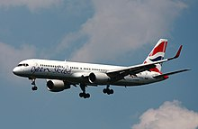

An OpenSkies Boeing 757-200 landing at Frankfurt Airport.

|  |  |  |  |
| --- | --- | --- | --- |
| **Airline** | **Still Owned by BA** | **Current Status** | **Details** |
| BA Cityflyer | Yes | Active | Founded 25 March 2007 as a reforming of the former subsidiary CityFlyer Express with assets of BA Connect not sold to Flybe |
| British Airways Engineering | Yes | Active | Responsible for the maintenance, repair, and overhaul of British Airways' aircraft. BAE was formed from the merger of the engineering divisions of BOAC and BEA's when the two airlines merged in 1974 to form British Airways. |
| British Airways World Cargo | No | Merged with fellow Cargo subsidiaries of IAG to form IAG Cargo | British Airways first opened a World Cargo centre at Heathrow in 1999. The company ended operations on 30 April 2014, having been fully merged into IAG Cargo |
| British Airways Helicopters | No | Sold | Sold in 1986 - Now trades as British International Helicopters |
| BA Connect | No | Closed | Formerly known as BA CitiExpress. Sold in 2007 to Flybe, closed down in 2020 |
| OpenSkies | Yes | Reorganised | Founded in 2008. OpenSkies ceased to operate under its own brand after summer 2018 to operate for IAG's new low-cost subsidiary brand Level. |
| British Airways Limited | No | Closed | Established in 2012 to take over the operation of the premium service between London City Airport and New York-JFK. The flights returned to be directly operated by British Airways plc in 2015. The service was suspended in March 2020 amidst COVID-19, before being officially cancelled in August 2020. |
| CityFlyer Express | No | Closed | Formerly a short-haul regional airline founded in 1991 (as Euroworld Airways). In 1993 it became the first British Airways (BA) franchisee operating as *British Airways Express*. City Flyer’s ownership passed to BA in 1999 when that company bought out the original promoters as well as 3i, the airline's main shareholder at the time. Initially, CityFlyer continued to operate as a separate unit, but it was eventually absorbed into British Airways' mainline short haul operation at Gatwick in 2001. |
| British Regional Airlines | No | Closed | Founded in March 1991 when Manx Airlines created Manx Airlines Europe in order to expand and fly routes within the United Kingdom. In 1994 Manx Airlines Europe became a franchise carrier for British Airways. In March 2001 British Airways purchased the British Regional Airlines Group (holding company of British Regional Airlines and Manx Airlines) for £78m and merged it with Brymon Airways to create British Airways CitiExpress. |
| Deutsche BA | No | Closed | Sold in 2008 to Air Berlin where it traded as dba by Air Berlin, before closing down in 2008 |
| Air Liberté | No | Closed | Purchased Air Liberté together with TAT and inaugurated them under one management. On 5 May 2000, BA sold Air Liberté to a partnership between Taitbout Antibes and Swissair. |
| BA Euroflyer | Yes | Active | Created in 2022, was established to compete with easyJet at Gatwick by providing a lower cost option to the primary airline. |

### **Franchises**

|  |  |  |  |
| --- | --- | --- | --- |
| **Airline** | **Still Operating** | **Still a BA Franchisee** | **Details** |
| Sun-Air | Yes | Active | Founded in 1978. Became a franchisee in 1996 |
| Comair | No | Closed | Founded in 1943. Became a franchisee in 1996. The company entered into voluntary business rescue proceedings on 5 May 2020, due to the impact of the coronavirus pandemic.Operations were suspended on 31 May 2022. |
| Loganair | No | Active | Founded in February 1962. In 1993, the airline became a franchisee of British Airways, operating its Islanders in the British Airways livery. This would stand until July 2008, when it became the new franchisee of Flybe. |
| Maersk Air UK | No | Closed | Founded in May 1993 as part of the demerger of BEA. It flew out of Birmingham Airport to domestic and European destinations under a British Airways franchise agreement. By early 2003 the Maersk Group had given up on operating an airline in the UK and put Maersk Air UK up for sale. However, there were not interested buyers and the company was therefore sold in a management buyout in 2003, with the airline becoming Duo Airways before ceasing operations in May 2004, when an investor withdrew support at short notice. |

### **Shareholdings:**

British Airways obtained a 15% stake in UK regional airline Flybe from the sale of BA Connect in March 2007. It sold the stake in 2014.

BA also owned a 10% stake in InterCapital and Regional Rail (ICRR), the company that managed the operations of Eurostar (UK) Ltd from 1998 to 2010, when the management of Eurostar was restructured.

### **Business trends:**

The key trends for the British Airways PLC Group are shown below.

On the merger with Iberia, the accounting reference date was changed from 31 March to 31 December; figures below are therefore for the years to 31 March up to 2010, for the nine months to 31 December 2010, and for the years to 31 December thereafter:

|  |  |  |  |  |  |  |  |  |  |  |  |  |  |  |  |
| --- | --- | --- | --- | --- | --- | --- | --- | --- | --- | --- | --- | --- | --- | --- | --- |
|  | **2008** **Mar** | **2009** **Mar** | **2010** **Mar** | **2010** | **2011** | **2012** | **2013** | **2014** | **2015** | **2016** | **2017** | **2018** | **2019** | **2020** | **2021** |
| Turnover (£m) | 8,758 | 8,992 | 7,994 | 6,683 | 9,987 | 10,827 | 11,421 | 11,719 | 11,333 | 11,443 | 12,226 | 13,021 | 13,290 | 4,001 | **3,693** |
| Profit (profit/loss after tax) (£m) | 694 | −358 | −425 | 170 | 672 | 84 | 281 | 702 | 975* | 1,345 | 1,447 | 2,091 | 1,109 | −3,489 | **−1,648** |
| Number of employees (average FTE) | 41,745 | 41,473 | 37,595 | 35,778 | 36,164 | 38,761 | 38,592 | 39,710 | 39,309 | 39,024 | 38,347 | 38,202 | 38,230 | 33,898 | **26,890** |
| Number of passengers (m) | 34.6 | 33.1 | 31.8 | 24.1 | 34.2 | 37.6 | 39.9 | 41.5 | 43.3 | 44.5 | 45.2 | 46.8 | 47.7 | 12.2 | **10.3** |
| Passenger load factor (%) | 79.1 | 77.0 | 78.5 | 78.5 | 78.2 | 79.9 | 81.3 | 81.0 | 81.5 | 81.2 | 81.8 | 82.5 | 83.6 | 61.4 | **58.3** |
| Number of aircraft at year end | 245 | 245 | 238 | 240 | 245 | 273 | 278 | 279 | 284 | 293 | 293 | 294 | 305 | 277 | **276** |
|  |  |  |  | only 9 months |  |  |  |  | *After deconsolidation of AGL |  |  |  |  |  |  |

In 2020, due to the crisis caused by the COVID-19 pandemic, British Airways had to reduce its 42,000-strong workforce by 12,000 jobs. According to the estimate by IAG, a parent company, it will take the air travel industry several years to return to previous performance and profitability levels.

However, 2022 saw a dramatic increase in travel, and the company now faced a worker shortage, forcing it to cancel more than 1,500 flights. During February 2023, the international airlines group, the owners of British Airways announced that the group has returned to making an annual profit of €1.3 billion for the first time since the pandemic, following a €2.8 billion loss in 2021. The company warned that due to the surge in demand for flying this could lead to more disruption.

### **Industrial relations**

Staff working for British Airways are represented by a number of trade unions, pilots are represented by British Air Line Pilots' Association, cabin crew by British Airlines Stewards and Stewardesses Association (a branch of Unite the Union), while other branches of Unite the Union and the GMB Union represent other employees. Bob Ayling's management faced strike action by cabin crew over a £1 billion cost-cutting drive to return BA to profitability in 1997; this was the last time BA cabin crew would strike until 2009, although staff morale has reportedly been unstable since that incident. In an effort to increase interaction between management, employees, and the unions, various conferences and workshops have taken place, often with thousands in attendance.

In 2005, wildcat action was taken by union members over a decision by Gate Gourmet not to renew the contracts of 670 workers and replace them with agency staff; it is estimated that the strike cost British Airways £30 million and caused disruption to 100,000 passengers. In October 2006, BA became involved in a civil rights dispute when a Christian employee was forbidden to wear a necklace bearing the cross, a religious symbol. BA's practice of forbidding such symbols has been publicly questioned by British politicians such as the former Home Secretary John Reid and the former Foreign Secretary Jack Straw.

Relations have been turbulent between BA and Unite. In 2007, cabin crew threatened strike action over salary changes to be imposed by BA management. The strike was called off at the last minute, British Airways losing £80 million. In December 2009, a ballot for strike action over Christmas received a high level of support, action was blocked by a court injunction that deemed the ballot illegal. Negotiations failed to stop strike action in March, BA withdrew perks for strike participants. Allegations were made by *The Guardian* newspaper that BA had consulted outside firms’ methods to undermine the unions: the story was later withdrawn. A strike was announced for May 2010, British Airways again sought an injunction. Members of the Socialist Workers Party disrupted negotiations between BA management and unite to prevent industrial action. Further disruption struck when Derek Simpson, a Unite co-leader, was discovered to have leaked details of confidential negotiations online via Twitter. Industrial action re-emerged in 2017, this time by BA's Mixed Fleet flight attendants, whom were employed on much less favourable pay and terms and conditions compared to previous cabin staff who joined prior to 2010. A ballot for industrial action was distributed to Mixed Fleet crew in November 2016 and resulted in an overwhelming yes majority for industrial action. Unite described Mixed Fleet crew as on "poverty pay", with many Mixed Fleet flight attendants sleeping in their cars in between shifts because they cannot afford the fuel to drive home, or operating while sick as they cannot afford to call in sick and lose their pay for the shift. Unite also blasted BA of removing staff travel concessions, bonus payments and other benefits to all cabin crew who undertook industrial action, as well as strike-breaking tactics such as wet-leasing aircraft from other airlines and offering financial incentives for cabin crew not to strike. The first dates of strikes during Christmas 2016 were cancelled due to pay negotiations. Industrial action by Mixed Fleet commenced in January 2017 after rejecting a pay offer. Strike action continued throughout 2017 in numerous discontinuous periods, resulting in one of the longest running disputes in aviation history. On 31 October 2017, after 85 days of discontinuous industrial action, Mixed Fleet accepted a new pay deal from BA which ended the dispute.

### **Senior Leadership**

* *Chairman:* Sean Doyle (since April 2021)
* *Chief Executive:* Sean Doyle (since October 2020)

#### **List of Former Chairmen**

1. Sir David Nicolson (1972–1975)
2. The Lord McFadzean (1976–1979)
3. Sir Ross Stainton (1979–1980)
4. The Lord King (1981–1993)
5. The Lord Marshall (1993–2004)
6. Sir Martin Broughton (2004–2013)
7. Keith Williams (2013–2016)
8. Álex Cruz (2016–2021)

#### **List of Former Chief Executives**

*The position was formed in 1977.*

1. Sir Ross Stainton (1977–1979)

2. Sir Roy Watts (1979–1983)

3. The Lord Marshall (1983–1995)

4. Bob Ayling (1996–2000)

5. Sir Rod Eddington (2000–2005)

6. Willie Walsh (2005–2010)

7. Keith Williams (2011–2016)

8. Álex Cruz (2016–2020)

**1.4 DESTINATIONS**

British Airways serves over 170 destinations in 70 countries, including eight domestic and 26 in the United States.

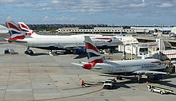

British Airways' former Airbus A318-100 parked at John F. Kennedy International Airport, New York City. This aircraft operated a special route between London and New York and was equipped with an all-business class configuration (named "Club World London City").

### **Alliances**

British Airways co-founded the airline alliance Oneworld in 1999 with airlines American Airlines, Cathay Pacific and Qantas.British Airways is still currently a member of Oneworld.

### **Codeshare agreements**

British Airways codeshares with the following airlines:

* Aer Lingus
* airBaltic
* Alaska Airlines
* American Airlines
* Bangkok Airways
* Cathay Pacific
* China Eastern Airlines
* China Southern Airlines
* Finnair
* Iberia
* Japan Airlines
* Kenya Airways
* LATAM Brasil
* LATAM Chile
* Loganair
* Malaysia Airlines
* Qantas
* Qatar Airways
* Royal Jordanian
* S7 Airlines
* TAAG Angola Airlines
* Vueling

**1.5 FLEET**

As of July 2021, the British Airways operates a fleet of 253 aircraft with 47 orders. BA operates a mix of Airbus narrow and wide-body aircraft, and Boeing wide-body aircraft, specifically the 777 and 787. In October 2020, British Airways retired its fleet of 747-400 aircraft. It was one of the largest operators of the 747, having previously operated the -100, -200, and -400 aircraft from 1974 (1969 with BOAC).

### **British Airways Engineering**

The airline has its own engineering branch to maintain its aircraft fleet, this includes line maintenance at over 70 airports around the world.As well as hangar facilities at Heathrow and Gatwick airport it has two major maintenance centres at Glasgow and Cardiff Airports.

## **1.6 MARKETING**

### **Branding**

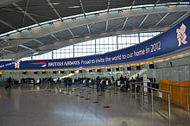

British Airways' promotional banner above the check-in desks at Heathrow Airport's Terminal 5.

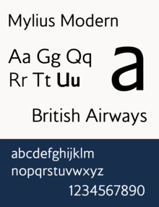

Mylius Modern, a custom-made typeface used by British Airways.

The musical theme predominantly used on British Airways advertising has been *"The Flower Duet"* by Léo Delibes.This was first used in a 1984 advertisement directed by Tony Scott, in an arrangement by Howard Blake.It was reworked by Malcolm McLaren and Yanni for 1989's iconic "Face" advertisement, and subsequently appeared in many different arrangements between 1990 and 2010. The slogan 'the world's favourite airline', first used in 1983, was dropped in 2001 after Lufthansa overtook BA in terms of passenger numbers. Other advertising slogans have included "The World's Best Airline", "We'll Take More Care of You", "Fly the Flag", and "To Fly, To Serve".

BA had an account for 23 years with Saatchi & Saatchi, an agency that created many of their most famous advertisements, including "The World's Biggest Offer “and the influential "Face" campaign. Saatchi & Saatchi later imitated this advert for Silverjet, a rival of BA, after BA discontinued their business activities. Since 2007, BA used Bartle Bogle Hegarty as its advertising agency.

In October 2022, BA launched a brand new ad campaign, titled "A British Original" produced by London-based Uncommon Creative Studio. This was to be another record-breaking campaign for its use of 500 unique executions along with a series of 32 short films, coinciding with the launch of Ozwald Boateng's new collection of uniform.

British Airways purchased the internet domain ba.com in 2002 from previous owner Bell Atlantic, BA being the company's acronym and its IATA Airline code.

British Airways is the official airline of the Wimbledon Championship tennis tournament, and was the official airline and tier one partner of the 2012 Summer Olympics and Paralympics.BA was also the official airline of England's bid to host the 2018 Football World Cup.

*High Life*, founded in 1973, is the official in-flight magazine of the airline.

### **Safety video**

The airline used a cartoon safety video from circa 2005 until 2017.Beginning on 1 September 2017 the airline introduced the new Comic Relief live action safety video hosted by Chabuddy G, with appearances by British celebrities Gillian Anderson, Rowan Atkinson,Jim Broadbent, Rob Brydon, Warwick Davis, Chiwetel Ejiofor, Ian McKellen, Thandie Newton, and Gordon Ramsay.A "sequel" video, also hosted by Chabuddy G, was released in 2018, with Michael Caine, Olivia Colman, Jourdan Dunn, Naomie Harris, Joanna Lumley, and David Walliams. The two videos are part of Comic Relief's charity programme.

### **Liveries, logos, and tail fins**

*Main article: History of British Airways § Liveries and logos*

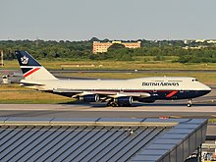

One of the four retro liveries to celebrate the 100th anniversary of British Airways and its predecessors. This Boeing 747-400 aircraft (registered as G-BNLY) is painted in the Landor Associates design.

The aeroplanes that British Airways inherited from the four-way merger between BOAC, BEA, Cambrian, and Northeast were temporarily given the text logo "British airways" but retained the original airline's livery. With its formation in 1974, British Airways' aeroplanes were given a new white, blue, and red colour scheme with a cropped Union Jack painted on their tail fins, designed by Negus & Negus. In 1984, a new livery designed by Landor Associates updated the airline's look as it prepared for privatization. For celebrating centenary, BA announced four retro liveries: three on Boeing 747-400 aircraft (one in each of BOAC, Negus & Negus, and Landor Associates liveries), and one A319 in BEA livery.

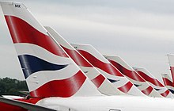

Current BA aircraft bear *Chatham Dockyard Union Flag* tail art.

In 1997, there was a controversial change to a new Project Utopia livery; all aircraft used the corporate colours consistently on the fuselage, but tailfins bore one of multiple designs.Several people spoke out against the change, including the former prime minister Margaret Thatcher, who famously covered the tail of a model 747 at an event with a handkerchief, to show her displeasure.BA's traditional rival, Virgin Atlantic, took advantage of the negative press coverage by applying the Union flag to the winglets of their aircraft along with the slogan "Britain's national flagcarrier".

In 1999, the CEO of British Airways, Bob Ayling, announced that all BA planes would adopt the tailfin design *Chatham Dockyard Union Flag* originally intended to be used only on the Concorde, based on the Union Flag.All BA aircraft have since borne the *Chatham Dockyard Union flag* variant of the Project Utopia livery, except for the four retro aircraft.

### **Arms**

Coat of arms of British Airways hide

|  |  |
| --- | --- |
| Armorial Bearings of British Airways.svg | **Notes**  Originally granted to the British Airways Board (1975), exemplified to British Airways Plc, pursuant to Royal License (1985).  **Adopted**  1975  **Crest**  On a Wreath of the Colours, rising from an Astral Crown Or, a Sun irradiated proper.  **Escutcheon**  Argent between a Chief and a Bendlet sinister coupled Gules, a Gyron issuing from the dexter, the point in sinister chief Azure.  **Supporters**  On the Dexter a Pegasus Argent crined, unguled and winged Or, gorged with an Astral Crown Azure, holding in the mouth a sprig of Olive fructed proper; on the Sinister, a Lion guardant winged at the shoulders Or and gorged with an Astral Crown Azure. The whole upon a compartment of a grassy mound proper dimidating water barry wavy Azure and Argent.  **Motto**  **TO FLY, TO SERVE** |

In 2011, British Airways made a brand relaunch project, in which BA introduced a stylized, metallized version of arms by For People Design to be used along with its *Speedmarque* logo. This is used exclusively on aircraft, First Wing Lounge and advertisements.

### **Loyalty programmes**

British Airways' tiered loyalty programme, called the Executive Club, includes access to special lounges and dedicated "fast" queues.Its program consists of six tiers: Blue, Bronze, Silver, Gold, Gold guest list and Premier.BA invites its top corporate accounts to join the "Premier" incentive programme.

The programme incentivises its members to fly with BA by awarding them Avios and Tier Points. Avios is the spending currency, which can be redeemed. Tier Points are a score used to determine the member's tier, and cannot be redeemed. Tier Points are reset at the end of each membership year, and Avios are retained for three years.

British Airways operates airside lounges for passengers travelling in premium cabins, and these are available to certain tiers of Executive Club members. First class passengers, as well as Gold Executive Club members, are entitled to use First Class Lounges. Business class passengers (called Club World or Club Europe in BA terms) as well as Silver Executive Club members may use Business lounges. At airports in which BA does not operate a departure lounge, a third-party lounge is often provided for premium or status passengers.

Members of the programme were also granted status within the Oneworld alliance, which permitted similar benefits when flying with Oneworld member airlines. The level of benefits were determined by the member's tier.

In 2011, due to the merger with Iberia, British Airways announced changes to the Executive Club to maximise integration between the airlines. This included the combination and rebranding of Air Miles, BA Miles and Iberia Plus points as the IAG operated loyalty programme Avios.

### **Inflight magazines**

***high life Magazine*** is British Airways' complimentary inflight magazine. It is available to all customers across all cabins and aircraft types.

***high life shop Magazine*** is British Airways' inflight shopping magazine. It is available to all customers on all aircraft where the inflight shopping range can be carried.

***First life*** is a complimentary magazine offered to all customers travelling in the First cabin. It has a range of articles including fashion, trends and technology with an upmarket target audience.

***Business life*** is a complimentary magazine targeted at business travellers and frequent flyers. The magazine can be found in all short haul aircraft seat pockets, in the magazine selection for Club World customers and in lounges operated by British Airways.

## **1.7 CABINS AND SERVICES**

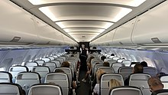

British Airways' Euro Traveller cabin, installed on all of the airline's narrow-body aircraft.

### **Short haul**

#### **Economy class**

*Euro Traveller* is British Airways' economy class cabin on all short-haul flights within Europe, including domestic flights within the UK. Heathrow and Gatwick-based flights are operated by Airbus A320 series aircraft. Standard seat pitch varies from 29" to 34" depending on aircraft type and location of the seat.

All flights from Heathrow and Gatwick have a buy on board system with a range of food designed by Tom Kerridge.Food can be pre-ordered through the British Airways mobile application. Alternatively, a limited selection can be purchased on-board using credit and debit card or by using Frequent Flyer Avios points. British Airways is rolling out Wi-Fi across its fleet of aircraft with 90% expected to be Wi-Fi enabled by 2020.

Scheduled services operated by BA Cityflyer currently offer complimentary onboard catering. The service will switch to buy on board in the future.

#### **Business class**

*Club Europe* is the short-haul business class available on all short-haul flights. This class allows for access to business lounges at most airports and complimentary onboard catering. The middle seat of the standard Airbus configured cabin is left free. Instead, a cocktail table folds up from under the middle seat on refurbished aircraft. Pillows and blankets are available on longer flights.

In-flight

### **Mid-haul and long haul**

#### **First class**

*First* is offered on all British Airways Airbus A380s, Boeing 777-300ERs, Boeing 787-9/10s and on some of the Boeing 777-200ERs. There are between eight and fourteen private suites depending on the aircraft type. Each First suit comes with a 6 ft 6 in (1.98 m) bed, a 15-inch (38 cm) wide entertainment screen, in-seat power and complimentary Wi-Fi access on select aircraft.

The exclusive Concorde Room lounge at Heathrow Terminal 5 offers pre-flight dining with waiter service and more intimate space. Dedicated British Airways 'Galleries First' lounges are available at some airports, and Business lounges are used where these are not available. Some feature a 'First Dining' section where passengers holding a first-class ticket can access a pre-flight dining service.

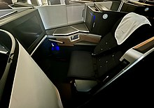

Club Suite seat unveiled in March 2019. It is featured in the Club World cabin on some of the aircraft.

#### **Club World**

*Club World* is the long-haul business class cabin. It is offered on all long-haul aircraft. The cabin features fully convertible flatbed seats. In March 2019, BA unveiled its new business-class seats on the new A350 aircraft, which feature a suite with a door. Since the unveiling, *Club Suite* has been installed on the Boeing 787-10 and retrofitted on some Boeing 777 cabins. The remaining aircraft are due to have their seats re-fitted over the coming years and they currently feature an older seat type, initially released in 2006.

#### **World Traveller Plus**

*World Traveller Plus* is the premium economy class cabin provided on all BA long haul aircraft. This cabin offers wider seats, extended leg-room, additional seat comforts such as larger IFE screen, a foot rest and power sockets. A complimentary 'World Traveller' bar is offered along with an upgraded main meal.

#### **World Traveller**

*World Traveller* is the mid-haul and long-haul economy class cabin. It offers seat-back entertainment, complimentary food and drink, pillows, and blankets. While the in-flight entertainment screens are available on all long-haul aircraft, international power outlets are available on the aircraft based at Heathrow. WIFI is also available on selected aircraft at an extra fee.

**1.8 INCIDENTS AND ACCIDENTS**

British Airways is known to have a strong reputation for safety and has been consistently ranked within the top 20 safest airlines globally according to *Business Insider* and *AirlineRatings.com.*

Since BA's inception in 1974, it has been involved in three hull-loss incidents (British Airways Flight 149 was destroyed on the ground at Kuwait International Airport as a result of military action during the First Gulf War with no one on board) and two hijacking attempts. To date, the only fatal accident experienced by a BA aircraft occurred in 1976 with British Airways Flight 476 which was involved in a mid-air collision later attributed to an error made by air traffic control.

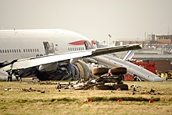

The damaged British Airways Flight 38, photographed on 17 January 2008.

* On 22 November 1974, British Airways Flight 870 was hijacked shortly after take-off from Dubai International Airport for London-Heathrow. The Vickers VC10 landed at Tripoli for refuelling before flying on to Tunis. The captain, Jim Futcher, returned to the aircraft to fly it knowing the hijackers were on board. A hostage, 43-year-old German banker Werner Gustav Kehl, was shot in the back. The hijackers eventually surrendered after 84 hours. Futcher was awarded the Queen's Gallantry Medal, the Guild of Air Pilots and Air Navigators Founders Medal, the British Air Line Pilots Association Gold Medal and a Certificate of Commendation from British Airways for his actions during the hijacking.
* On 10 September 1976, a Trident 3B on British Airways Flight 476 departed from London-Heathrow to Istanbul. It collided in mid-air with an Inex Adria DC9-31 near Zagreb. All 54 passengers and 9 crew members on the BA aircraft died. This is the only fatal accident to a British Airways aircraft since the company's formation in 1974.
* On 24 June 1982, British Airways Flight 9, a Boeing 747-200 registration *G-BDXH*, flew through a cloud of volcanic ash and dust from the eruption of Mount Galunggung. The ash and dust caused extensive damage to the aircraft, including the failure of all four engines. The crew managed to glide the plane out of the dust cloud and restart all four of its engines, although one later had to be shut down again. The volcanic ash caused the cockpit window to be scratched to such an extent that it was difficult for the pilots to see out of the plane. However, the aircraft made a successful emergency landing at Halim Perdanakusuma International Airport just outside Jakarta. There were no fatalities or injuries.
* On 10 June 1990, British Airways Flight 5390, a BAC One-Eleven flight between Birmingham and Málaga, suffered a windscreen blowout due to the fitting of incorrect bolts the previous day. The captain sustained major injuries after being partially blown out of the aircraft, but the co-pilot landed the plane safely at Southampton Airport.
* On 2 August 1990, British Airways Flight 149 landed at Kuwait International Airport four hours after the Iraqi invasion of Kuwait. The aircraft, a Boeing 747-100 *G-AWND*, was destroyed, and all passengers and crew were captured. Two of the landing gears were salvaged, and are on display in Waterside, BA Headquarters in London.
* On 29 December 2000, British Airways Flight 2069 was en route from London to Nairobi when a mentally ill passenger entered the cockpit and grabbed the controls. As the pilots struggled to remove the intruder, the Boeing 747-400 stalled twice and banked to 94 degrees. Several people on board were injured by the violent manoeuvres, which briefly caused the aircraft to descend at 30,000 ft per minute. The man was finally restrained with the help of several passengers, and the co-pilot regained control of the aircraft. The flight landed safely in Nairobi.
* On 17 January 2008, British Airways Flight 38, a Boeing 777-200ER *G-YMMM*, from Beijing to London crash-landed approximately 1,000 feet (300 m) short of Heathrow Airport's runway 27L, and slid onto the runway's displaced threshold. The aircraft sustained damage to its landing gear, wing roots, and engines, resulting in the first hull loss of a Boeing 777. There were no fatalities, but there was one serious injury and 12 minor injuries. The accident was caused by icing in the fuel system, resulting in a loss of power.
* On 24 May 2013, British Airways Flight 762, using an Airbus A319-131 and registered as G-EUOE, returned to Heathrow Airport after fan cowl doors detached from both engines shortly after takeoff. During the approach, a fire broke out in the right engine and persisted after the engine was shut down. The aircraft landed safely with no injuries to the 80 people on board. The accident report revealed that the cowlings had been left unlatched following overnight maintenance. The separation of the doors caused airframe damage and the right-hand engine fire resulted from a ruptured fuel pipe.
* On 22 December 2013, British Airways Flight 34, a Boeing 747-436 *G-BNLL*, hit a building at O. R. Tambo International Airport in Johannesburg after missing a turning on a taxiway. The starboard wing was severely damaged but there were no injuries amongst the crew or 189 passengers, however, four members of ground staff were injured when the wing smashed into the building. The aircraft was officially withdrawn from service in February 2014.
* On 8 September 2015, British Airways Flight 2276, a Boeing 777-236ER *G-VIIO*, aborted its takeoff at Las Vegas' McCarran International Airport due to an uncontained engine failure of its left (#1) General Electric GE90 engine, which led to a substantial fire. The aircraft was evacuated on the main runway. All 157 passengers and 13 crew escaped the aircraft, at least 14 people sustaining minor injuries.
* Between 21 August 2018 and 5 September 2018, hackers carried out a "sophisticated, malicious criminal attack" on the website of the airline. Around 380,000 transactions were affected by this web skimming attack. The company was subsequently fined £183 million (1.5% of turnover) in July 2019, by the Information Commissioner's Office, the highest ever fine handed by the ICO at the time of issuing.
* On 18 June 2021, a British Airways Boeing 787-8 *G-ZBJB*, had a nose landing gear collapse while on the tarmac at Heathrow Airport. A British Airways spokesperson confirmed that no passengers were on board the plane when the incident occurred.
* On 6 July 2022, British Airways Flight 820, an Airbus A320-232, caught fire as it was landing at Copenhagen Airport. Airport firefighters put out the fire. They had to use foam as well. People in the terminal buildings were able to record the footage. The plane was ferried back to London-Heathrow Airport on July 9.

**1.9 BRITISH AIRWAYS WORLD CARGO**

British Airways World Cargo, formerly British Airways Cargo, was a division of IAG Cargo, operating air cargo services under the British Airways brand. It was the twelfth-largest cargo airline in the world by total freight tonne-kilometres flown. Freight services were provided using the main British Airways fleet, as well as dedicated freighter aircraft operating under a wet lease agreement with Global Supply Systems.

British Airways first opened a World Cargo centre at Heathrow in the late 1990s;it was an automated freight handling centre capable of handling unusual and premium cargo, and fresh produce, of which it handled over 80,000 tons per year.BA World Cargo also handled freight at London's Gatwick and Stansted airports, and, through its partner British Airways Regional Cargo, at all of the main regional airports throughout the UK.

The company ended operations on 30 April 2014, having been fully merged into IAG Cargo, however without continuing dedicated cargo flights. BA World Cargo also operated an automated cargo centre at London Heathrow Airport, and had a base for long-haul freighter services at London Stansted Airport.

Following the shuttering of British Airways World Cargo, a new all-cargo airline, CargoLogicAir, commenced operations in 2015, receiving some staff from Global Supply Systems.

BA World Cargo operated dedicated freighter aircraft services to Africa, the Middle East, the Indian Subcontinent, East Asia, North America and Europe from their London-Stansted base. BA World Cargo operates using the main BA fleet. Until the end of March 2014 they also operated three Boeing 747-8 freighter aircraft providing dedicated long-haul services under a wet lease arrangement from Global Supply Systems.

BA World Cargo fleet as at April 2014 consisted of:

* Boeing 747-8F (total of 3 were wet-leased from Global Supply Systems and phased out gradually)

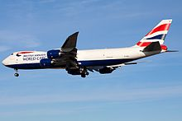

Boeing 747-8F

BA World Cargo also used space on dedicated freighters operated by other carriers.

**Previously operated**

* Boeing 707-320C
* Boeing 747-200F
* Boeing 747-400F
* Vickers 953c Merchantman

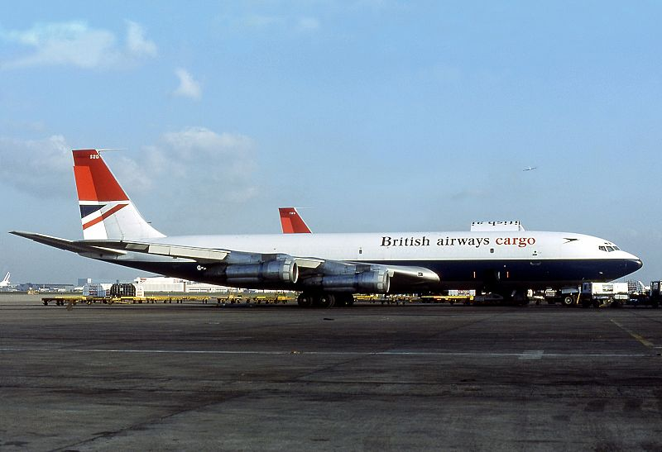

Boeing 707-320C

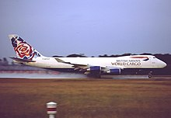

Boeing 747-400F

**1.10 BRITISH AIRWAYS LOGO**

British Airways was founded in 1974, two years after the merger of British European Airways and British Overseas Airways Corporation. She was loved and hated, but she continued to maintain high standards, strive for excellence, and do challenging things. Perhaps the most violent reaction was BA’s decision to decorate the tail fin with ethnic designs – each country has its design. This is how the company wanted to express cosmopolitanism, but the public did not understand it. It got to the point that Prime Minister Margaret Thatcher harshly condemned the new concept, throwing a headscarf over a model aircraft under the gun of the world’s media.

### 1974 – 1984

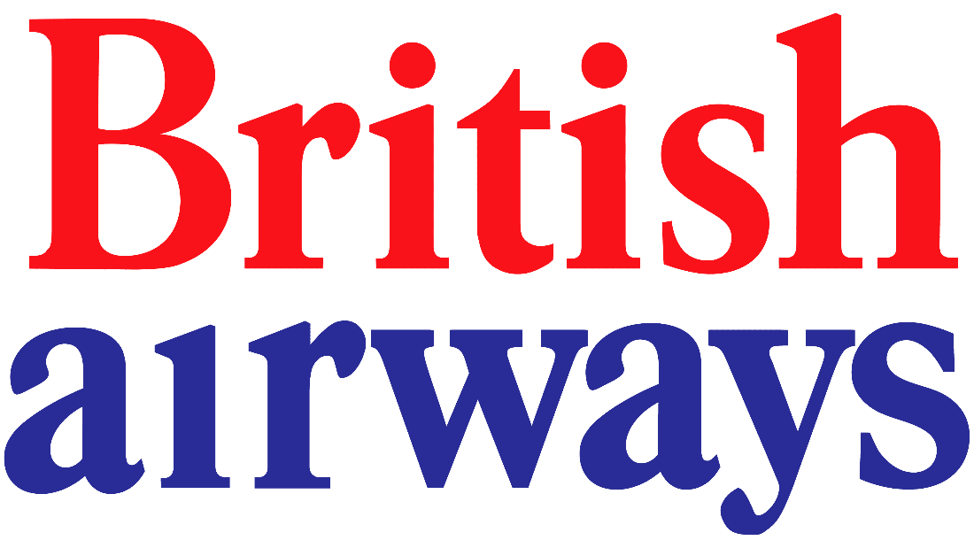

BEA and BOAC already had their branding ideas, so the designers tried to combine them. Negus & Negus made a compromise and created a simple two-color lettering emblem. It was the red and blue name of British Airways, split into two lines.

There was no dot above the “i” in the word “airways,” which did not characterize the company from the best side. And there was also no dynamics in the image, which was supposed to support the air carrier’s image. This not-so-perfect identity reflected the industry’s problems: ineffective management methods and, as a result, customer dissatisfaction.

### 1984 – 1997

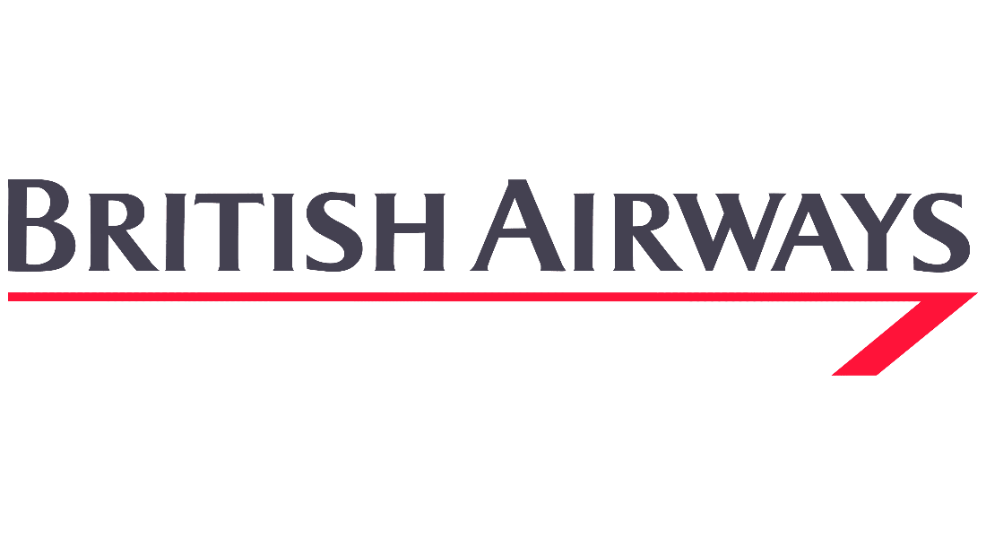

The second version of the logo appeared in 1984. It was developed by the American firm Landor Associates, which caused a controversial reaction in British society due to the unspoken ban on cooperation with foreign design agencies. The name of the airline was written in one line and capital dark gray letters. In this case, the first “B” and “A” were slightly higher.

A long red line, curved in an arrow shape, appeared under the caption. She seemed to emphasize the pedantry and dismissive superiority of the British. The new logo was supposed to reflect BA’s corporate culture and confirm the company’s primacy

### 1997 – 2008

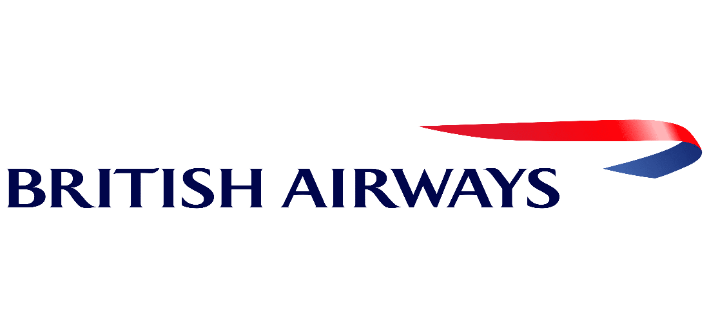

This logo is the result of collaboration with Newell & Sorrell. Representatives from the design agency helped British Airways shed its stuffy British image, which hindered the company from achieving international recognition in the eyes of customers. The final version of the emblem was unveiled on June 10th.

On the right was an elegant ribbon called the Speedmarque. It symbolized speed, movement, and innovation, which became the key values of the airline. This symbol was used on the fuselage of aircraft, company uniforms, boarding passes, and other locations associated with the British Airways brand. The ribbon was divided into two colors:

* red – representing strength, dynamism, and energy;
* blue – reflecting quality, reliability, and professionalism.

The airline borrowed these colors from its predecessors, BOAC and BEA. To make the logo look bright and modern, the designers added a gradient. The “BRITISH AIRWAYS” inscription on the left was also dark blue but without the shade transition. It looked original due to the “floating” serif font called Mylius.

### 2008 – today

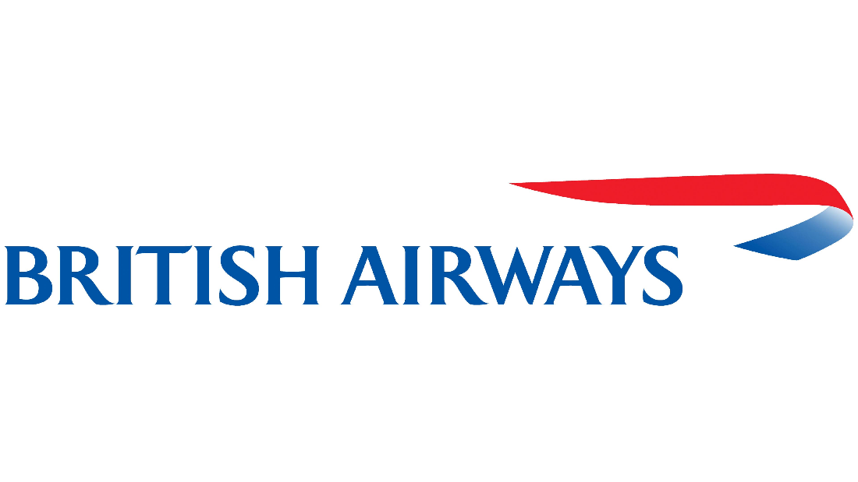

In 1997, branding agency Newell & Sorrell developed a new corporate identity for British Airways because the old one was “too British.” So, the airline decided to show its globalization, focus on international air transportation. The nineties’ internationalism was embodied in a red and blue symbol that looked like a waving scarf. Below, aligned to the left, was the name of the firm, written in uniform-sized blue capital letters

**1.11 10 BRITISH AIRWAYS AIRLINE FACTS**

***1. BA first flight carried only one passenger and launched the world’s first daily international scheduled air service between London and Paris.***

On 25 August 1919 Aircraft Transport and Travel Limited (AT&T), a forerunner company of British Airways, launched the world’s first daily international scheduled air service, between London and Paris. That first flight, which took off from Hounslow Heath, close to today’s Heathrow Airport, carried a single passenger and cargo that included newspapers, Devonshire cream, jam and grouse.

***2. British Airways is the world’s largest operator of the Boeing 747-400.***

The Boeing 747-400 is a wide body, four-engine jet manufactured by Boeing, the American aerospace company. Its distinctive upper deck shape has earned it the nickname “Jumbo Jet”. BA is the world’s largest operator of the Boeing 747. The 747-400 is a proven performer with high reliability and incorporates major aerodynamic improvements over earlier 747 models, including the addition of winglets to reduce drag, new avionics, and a new flight deck.

***3. International Airlines Group (IAG) announced a joint business agreement between British Airways and Qatar Airways.***

International Airlines Group (IAG) announced a joint business agreement on October 30, 2016 between British Airways and Qatar Airways.

The joint business will benefit customers by providing better links between the UK, continental Europe, Asia, Middle East and Africa, with a greater choice of flights and enhanced frequent flyer benefits. The revenue-sharing agreement will allow the airlines to cooperate on scheduling and pricing, providing customers with more flexible options and an attractive range of fares.

Customers will be able to travel more easily on the airlines’ combined route network. The joint business will see the two airlines code-sharing on all non-stop flights operated between the UK and Doha and connecting services to destinations in the UK, continental Europe, Middle East, Asia and Africa. This will include British Airways’ daily direct flights from London Heathrow to Doha.

This agreement will also strengthen the oneworld alliance and enable it to compete more effectively on these routes.

***4. British Airways and Air France operated the supersonic airliner Aerospatiale-BAC Concorde, and the world’s first supersonic passenger service flew in January 1976 from London Heathrow to Bahrain.***

The first supersonic passenger-carrying commercial airplane (or supersonic transport, SST), built jointly by aircraft manufacturers in Great Britain and France. The Concorde made its first transatlantic crossing on September 26, 1973, and it inaugurated the world’s first scheduled supersonic passenger service on January 21, 1976—BA initially flying the aircraft from London to Bahrain and Air France flying it from Paris to Rio de Janeiro. Both airlines added regular service to Washington, D.C., in May 1976 and to New York city in November 1977.

British Airways Concorde made just under 50,000 flights and flew more than 2.5m passengers supersonically. With a takeoff speed of 220 knots (250mph) and a cruising speed of 1350mph – more than twice the speed of sound – a typical London to New York crossing would take a little less than three and a half hours as opposed to about eight hours for a subsonic flight. In November 1986 a British Airways Concorde flew around the world, covering 28,238 miles in 29 hours, 59 minutes

***5. British Airways has affected more than 1,000 flights when BA suffered a computer power failure. All flights were cancelled, and thousands of passengers were affected.***

The airline was hit by a worldwide computer system power failure, causing cancellations and delays for thousands of passengers.

More than 1,000 flights were affected. At Heathrow alone, BA had 406 flights scheduled to depart after 9am and a further 71 at Gatwick, according to flightstats.com.

The chaos happened just after 11am on 27 May 2017 when the company’s unreliable new IT system crashed worldwide for the sixth time in a year.

***6. The British Airways has its own engineering branch to maintain its aircraft fleet, this includes line maintenance at over 70 airports around the world.***

British Airways Engineering has over 80 years of experience in providing maintenance, repair and overhaul services to British Airways and other customers, operational expertise has fostered a can-do culture centered on finding solutions. BA have invested in state-of-the-art aircraft maintenance, avionic, interiors and mechanical workshop facilities and have a worldwide reputation for engineering excellence. Technically good solutions are shared, and this saves our customers millions.

BA maintain an impressive range of aircraft in our extensive facilities. Based in the UK, BA team of 2000 highly skilled engineers working across 30 hangar bays can execute any requirements you have, from a rapid response casualty unit through to major maintenance and structural repairs. BA are focused on safety, delivery, reliability and value.

***7. British Airways purchased the internet domain ba.com in 2002 from previous owner Bell Atlantic, ‘BA’ being the company’s acronym and its IATA Airline code.***

BA, one and the same as ba.com and one of the simplest-to-remember websites in the business: ba.com.

That’s Bell Atlantic’s site – or at least it was before Martin Lock got involved. He was marketing and e-commerce director for Excel Airways, while heading UK e-commerce for British Airways, he realized it was crucial for the airline to own the web address ba.com

Lock spent a year wresting ba.com from its previous owners (the price remains a secret), then had to spend months persuading BA executives that simple was best, and that britishairways.com was too cumbersome. He has been vindicated by the airline’s emphasis on ba.com – but Lock now finds himself in competition with the site he created.

***8. In 2013, British Airways became the first commercial airline in Europe to operate both the Airbus A380 and Boeing 787 Dreamliner.***

On July 4, 2013, British Airways debuted the future of its fleet by making a rare, if not unprecedented move. Two new airliners, the Airbus A380 and Boeing 787 were introduced simultaneously at a special ceremony for media and dignitaries at London’s Heathrow Airport. Not only are both aircraft being delivered and unveiled at the same time, but British Airways will be the first airline to operate and take delivery of both the A380 and 787 in a single fleet.

***9. British Airways powers its future by turning household rubbish into jet fuel.***

British Airways has entered a partnership to design a series of waste plants that convert household waste into renewable jet fuel to power its fleet.

The partnership, with Velocys, a renewable fuels company, is part of the airline’s plans to develop long-term, sustainable fuel options**.**

The first plant will take hundreds of thousands of tons of household waste per-year, destined for landfill or incineration, including nappies, plastic food containers and chocolate bar wrappers, and convert it into clean-burning, sustainable fuels. This will contribute to the airline’s commitment to reduce net emissions by 50 per cent by 2050.

***10. British Airways i360 the tallest moving observation tower in the world.***

The tower has been acknowledged by Guinness World Records as the world’s most slender tower, with a height-to-width ratio of more than 40-1.

British Airways i360 is a 162-metre (531 ft) observation tower on the seafront of Brighton, East Sussex, England at the landward end of the former West Pier. The tower opened on 4 August 2016. From the fully enclosed viewing pod, visitors experience 360-degree views across Brighton, the South Downs, the English Channel and on the clearest days it is possible to see Beachy Head 17 miles (27 km) to the east and the Isle of Wight 49 miles (79 km) to the west.

According to the operator, the “i” in the title stands for “intelligence, innovation and integrity”.

**1.12** **BRITISH AIRWAYS HEALTH SERVICE**

Commercial air travel is a comfortable, speedy and safe means of transport and is now accepted as a part of everyday life for many people in the developed world. It is affordable and accessible to all sectors of the population and it is easily forgotten that the individual is travelling in an unfamiliar and physiologically unusual environment. For the fit, healthy and mobile individual there is no problem but for the passenger with certain pre-existing conditions or developing an acute medical problem in flight, the cabin environment may exacerbate the condition.

In-flight medical problems can result from the exacerbation of a pre-existing medical condition or can be an acute event occurring in a previously fit individual. Although the main problems relate to hypoxia and expansion of trapped gases, the stress and physical challenge to passengers of the complex airport environment should not be overlooked (e.g. carrying baggage, walking long distances and dealing with unexpected delays).

Cabin Crew receive training in advanced first aid and basic life support and in the use of the emergency medical equipment, including automated external defibrillators which are carried on board all British Airways aircraft. In the future, British Airways intends to install air-to ground cardiac monitors to assist with diagnosis. In serious cases assistance will be requested from the airline’s medical advisers via the air-to-ground link or a medical professional who may be travelling as a passenger.

In a medical emergency, other (non-medical) factors need to be taken into account when considering whether a diversion is appropriate, including:

* suitable convenient airport
* appropriate medical facilities
* terminal facilities for the number of passengers
* sufficient hotel accommodation for passengers and crew

Most airlines provide services for those passengers requiring extra help but these can be made available only if the airline is advised of the need for special assistance by the passenger or his/her medical practitioner prior to the flight. Most airlines also have a medical adviser to assess the fitness for travel of those with medical needs. The information needed for provision of appropriate assistance depends upon an understanding of the practicalities of air travel as well as an understanding of the basic physics of the flight environment and its effect on human physiology.

The operational effect of the use of equipment such as wheelchairs, ambulances and stretchers must be taken into account and the possibility of aircraft delays or diversion to another airport must be considered. It may be necessary to change aircraft and transit between terminals during the course of a long journey and land-side medical facilities will not be available to a transiting passenger. At London’s Heathrow Airport, for example, transfer traffic accounts for more than 40% of all passengers.

Deterioration on holiday or on a business trip of a previously stable condition such as asthma, diabetes or epilepsy or accidental trauma frequently gives rise to a request for medical clearance for the return journey. A stretcher may be required, together with medical support and this can incur considerable cost. Hence the importance of adequate travel insurance which includes the provision of a specialist repatriation company.

Aside from the considerations specific to flying, thought should, of course, also be given to immunisation and anti-malarial prophylaxis where appropriate, adverse effects of the destination climate, inadequate health resources and the potential impact of lost or stolen medication.

***Pre-flight Assessment and Medical Clearance***

The ideal traveller is one who is fully vaccinated, insured, taking appropriate protection measures, aware of potential risks, prepared for the demands of the journey (both on the ground and in the air) and fully conversant with their destination. (For example, Mexico City with its high pollution levels and an altitude above 9,500 feet should not be contemplated by those with respiratory impairment.)

***Objective***

The objectives of medical clearance are to provide safe, healthy travel, high levels of customer satisfaction and to prevent delays and diversions to the flight as a result of a deterioration in the passenger’s well-being. It depends, however upon self-declaration by the passenger and upon the attending physician having an awareness of the flight environment and how this might affect the patient’s condition.

***Mechanism***

Early notification to the airline is essential to ensure communication to operational areas for pre-board and baggage assistance, provision of buggies or wheelchairs for distances, special diets and seating.

The Aerospace Medical Association has published guidelines on fitness for travel and the International Air Transport Association (IATA) publishes a recommended Medical Information Form (MEDIF) for use by member airlines. This is available from the airlines directly or from travel agents.

Part 1 of the MEDIF is completed by the agent and/or passenger and Part 2 by the passenger’s medical representative. It should then be passed to the airline at the time of booking to ensure timely medical clearance. It is essential that the form is fully completed as delays can result if information is omitted.

***The need for Medical Clearance***

Medical clearance is required when:

* ***fitness to travel is in doubt*** as a result of recent illness, hospitalisation, injury, surgery or instability of an acute or chronic medical condition ·
* ***special services are required*** e.g., oxygen, stretcher or authority to carry or use accompanying medical equipment.
* passengers are contemplating overseas diagnostic or hospital treatment in specialist hospitals. There is still the need to conform to airline requirements for medical clearance.

***Assessment***

***Physiological Consideration***

Basic principles of physics, physiology and pathology should be used in determining the passenger’s fitness to fly.

Modern commercial airliners fly with a cabin altitude of between 4000 and 8000 feet when at cruising altitude, which means a reduction in ambient pressure of the order of 20% compared with sea level and a consequent reduction in blood oxygen saturation of about 10%.Consideration must be given therefore to the effects of the relative hypoxia encountered.

Any trapped gas will expand in volume by up to 30% at the normal aircraft cabin cruise altitude, potentially leading, for example to pain and perforation of the ear drum if the Eustachian tubes are blocked by infection or to stretching of suture lines following recent abdominal surgery.

The cabin air is relatively dry which can lead to a sensation of dryness in the mouth and extremities, though studies have shown that it does not lead to central dehydration and plasma osmolality is unchanged.

The potential for the development of traveller’s thrombosis, particularly on long haul routes, should be borne in mind. Many airlines (including British Airways) promote lower limb exercise in the in-flight magazine and encourage mobility within the cabin. However, those passengers known to be vulnerable to DVT (for example with clotting disorders, recent surgery or trauma and those with certain types of malignancy) should undergo appropriate medical evaluation, and consideration given to the use of compression stockings, aspirin or anti-coagulants.

In addition to the effect of the condition upon the sick passenger, account must be taken of the effect or potential effect on other passengers or crew members. It is important to recognise that the filters for re-circulating cabin air remove bacteria and most viruses, so that any risk of transmission of infection in the cabin is remote and usually confined to those passengers seated near to the infected passenger. However, it is an International Health Regulation that an individual should not fly during the infectious stage of a contagious disease.

***Practical Considerations***

The best time to establish the fitness of the prospective passenger for a commercial airline flight is in the weeks prior to the intended departure.

The pre-flight evaluation should focus on the passenger’s medical condition with special consideration given to possible infectivity, the dosage and timing of any medication and the need for special assistance requests. The physician can achieve much by simply reminding passengers to hand carry life-line medication and by endorsing the need for valid travel insurance which includes adequate health cover.

***Criteria***

Examples of conditions requiring particular evaluation include cardiovascular disease, deep vein thrombosis, upper and lower respiratory tract disease (e.g., sinusitis, asthma, chronic obstructive airways disease, emphysema), recent surgery, cerebro-vascular disease, unstable psychiatric illness, diabetes and infectious diseases.

Assessment is often relatively simple. For example, a knowledge of the passenger’s exercise tolerance can be a useful indication of fitness to fly. If someone is unable to walk a distance greater than 50 metres without developing dyspnoea, there is a risk that they will be unable to tolerate the relative hypoxia of the pressurised cabin. More specific information can be gained, if necessary, from a knowledge of the passenger’s blood gas levels and oxygen saturation.

Operational airline crew are familiar with the risk of otic barotrauma from flying with an upper respiratory tract infection, hay fever or sinusitis but passengers may need to be reminded of this potential hazard. It is also considered unwise to travel by air with otitis media unless appropriate antibiotics have been administered for at least 36 hours and the patency of the Eustachian tubes assessed by a health professional.

It is advisable to carry written confirmation of non-infectivity, for example when jaundiced. Similar documentation is wise if carrying medication to satisfy customs at ports of entry.

One other important point is to avoid prescribing a medication for in-flight use unless the would-be traveller has used it before, is familiar with its primary effects and has no undue side effects.

Waivers and disclaimers are inappropriate and are not recommended practice.

***Medical Criteria for Fitness to Fly***

There are a number of contraindications to flying that are absolute, many more of which are relative. The following guidelines are in use in ***British Airways***, which are, in turn, based on those issued by IATA (the International Air Transport Association). It is impossible to give definitive advice for every condition and the information provided is for guidance only and may be varied for reasons such as complications or multiple pathology.

Medical escorts may be required if there is a high level of dependency or if there is a significant risk of deterioration. In all cases, passengers must be reminded to carry into the cabin with them any medication that might be required in flight.

***Some Medical Conditions Requiring Pre-Flight Medical Evaluation:***

***Cardio-******Vascular Disease***

Examples include recent ***myocardial infarction, coronary artery bypass*** ***grafting , angina pectoris and congestive cardiac failure***

Most cardiac patients on medication can tolerate cabin air if stable, with the use of supplementary oxygen in some cases.

Following an uncomplicated myocardial infarction, passengers should not fly for at least 7 days. Angina, if stable with infrequent attacks, is not usually a problem.

***Coronary artery bypass grafting*** and other ***chest surgery*** should pose no risk providing the passenger has made a normal uncomplicated recovery. Air travel can be contemplated, if necessary, at 10 days post surgery, thus allowing time for the air introduced into the chest to be reabsorbed. The situation following the relatively new procedure of ***angioplasty*** (with or without stent) is less clear because of the risk of early re-occlusion. In most cases travel can be contemplated within 3 to 5 days but individual assessment is required.

***Respiratory Disease***

Passengers with asthma and chronic lung disease (including chronic obstructive pulmonary disease (COPD) and pulmonary fibrosis) are usually able to travel safely if the condition is stable and there has been no recent deterioration.

One method for use by the physician when making an assessment is to check whether the passenger can walk 50 metres on the flat or up one flight of stairs without becoming severely dyspnoeic. If the answer is “yes” then the passenger is likely to be fit to fly; if “no” most of the passengers may be transported safely and without incident providing that supplemental oxygen is available during the flight as standby or for continuous use. Individuals who are markedly breathless at rest should be advised not to fly.

For borderline cases or when oxygen is required on the ground (and the trip is essential), measurements of oxygen saturation and/or blood gas analysis can be useful. Although the percentage of oxygen remains constant at around 21% whatever the altitude, the partial pressure of oxygen in the cabin at the highest cruising altitude can be considered to be equivalent to an oxygen concentration of approximately 17% at sea level. Some respiratory physicians therefore, have assessed oxygen saturation levels on patients whilst breathing 16- 17% oxygen as a definitive test of fitness to fly. More information on the provision of in-flight oxygen can be found below.

There is no specific risk to passengers with asthma in the aircraft cabin, the most significant problem encountered is when medication is inadvertently packed in the hold. For travellers to areas of the world where health care provision may not be readily available, it may be prudent for all but the mildest asthmatics to be advised to take a course of steroids with them for use in an emergency.

***Pneumonia*** should be resolved, with no residual infection and satisfactory exercise tolerance as above. If the passenger also has existing pathology (such as COPD) it is often prudent to delay travel for a few weeks if possible.

Under conditions of reduced pressure, gas trapped in the body cavities will expand and this must be considered following a pneumothorax. Generally, it should be safe to travel by air two weeks after successful drainage.

***Blood Disorders***

For passengers with anaemia special consideration should be given to anyone with a haemoglobin below 7.5gm/dl as it reduces the tolerance to hypoxia. If there is any doubt oxygen should be considered.

Those with chronic renal failure and other conditions predisposing to anaemia, usually tolerate a lower haemoglobin level at cabin cruising altitude than someone with a recent haemorrhage.

Those with sickle cell anaemia should travel with supplemental oxygen and should defer travel for 10 days following a sickling crisis.

Sickle cell trait has not been associated with problems at normal cruising altitude.

***Central Nervous System Disorders***

Following a stroke or cerebrovascular accident, passengers can usually travel after 3 days if stable or recovering, though formal medical clearance should be sought if travel is required within 10 days. For those with cerebral artery insufficiency, hypoxia may lead to problems and supplementary oxygen may be advisable.

Travel should be delayed for 24 hours after a grand mal seizure. The passenger with stable epilepsy may be more prone to seizures during a long flight; mild hypoxia and hyperventilation are known precipitating factors, in addition to the aggravation of fatigue, anxiety and irregular medication. Whilst it would not be appropriate to change medication immediately prior to a trip, consideration should be given to providing extra anti-convulsant medication. If nothing else, the passenger with epilepsy must ensure that they have sufficient medication in their hand baggage for the duration of the flight and also for any unexpected delays.

***Deep Vein Thrombosis (DVT)***

Those with a DVT of the leg can travel once the condition is stabilised on an appropriate anticoagulation regime with resolution of the clot.

Prolonged immobility is a known risk factor for thrombo-embolic disease and all passengers should keep mobile whilst in flight. It is recommended that they stand in their seat area and stretch their arms and legs every couple of hours, walk around the cabin whenever they can and follow an in-seat exercise programme. Such as that contained in the British Airways in flight magazine, High Life.

Passengers with intrinsic risk factors, such as a history of DVT or pulmonary embolism, post thrombotic syndrome, chronic venous insufficiency, malignancy, coagulopathy, heart disease or pregnancy, should, in addition, seek medical advice and take appropriate precautions. Prophylaxis with low molecular weight heparin or aspirin may be appropriate.

***ENT Disorders***

Otitis media, sinusitis and any other condition leading to blockage of the Eustachian tube may lead to problems because of gas expansion. Pain, perforation of the tympanic membrane and sinus barotrauma can result and flying should be delayed until the condition has resolved.

Passengers can fly 10-14 days after tonsillectomy or middle ear surgery. If the jaw has been wired for any reason, a passenger may only travel if there is an escort equipped with wire cutters or a self-quick release mechanism is fitted.

***Fractured Limbs***

Following application of a plaster cast, British Airways restricts flying for 24 hours for flights under 2 hours and 48 hours for longer flights. However, these restrictions do not apply if the cast has been bi-valved which helps to avoid harmful swelling, particularly on long flights. Full length, above the knee plasters or those who require leg elevation are required to purchase appropriate seating (First, Club World or extra seats in World or Euro Traveller) in order to obtain the necessary leg room. Fractures of the hip or femur will almost certainly require a stretcher. Safety regulations preclude the use of Emergency Exit rows for any passenger with a medical condition.

***Gastro-Intestinal Disease***

Passengers who have had abdominal surgery in which hollow viscus has been sutured are at risk of perforation or haemorrhage as a result of gas expansion at altitude. Air travel should be discouraged for 10 days following any abdominal surgical procedure. In addition, stretching gastric or intestinal mucosa may result in haemorrhage from ulcer sites although travel may be permitted if there is clear endoscopic evidence of healing.

Travellers with colostomies are not at increased risk during air travel although intestinal distension may increase faecal output. The use of a large colostomy bag is recommended. More frequent changes may be necessary for smaller bags and extra supplies should be carried in the cabin hand baggage.

Passengers may experience abdominal discomfort because of gas expansion in flight but this is not of significant medical concern.

***Infectious Diseases***

In common with other public transport systems, an airline cannot accept passengers with infectious conditions until the risk to other passengers has passed.

***Diabetes Mellitus***

As long as they can administer their own medication passengers with diabetes mellitus can usually travel without difficulty and medical clearance is not required. It is important that they are aware of problems caused by time zone changes. It is recommended to remain on one time system during the flight and only attempt to readjust to local time on arrival at their destination.

For flights over 8 hours a specialist doctor or nurse should advice regarding an insulin regime.

Diabetics also need to be reminded that insulin does not generally require refrigeration. The British Diabetic Association recommend carriage of insulin in the hand baggage and not in the aircraft hold where it is possible that the insulin may be frozen and so become inactivated. Needles should be disposed of safely and never in seat pockets or toilets. Further information on diabetes and travel is available on the British Diabetic Association website at www.diabetes.org.uk. Special diets can be requested at the time of making a reservation. It is often sensible to specify what the dietary requirements are rather than just asking for a “diabetic meal”.

***Ophthalmological Procedures***

Procedures for retinal detachment can involve the intra-ocular injection of gas in order to temporarily increase intra-ocular pressure. This gas bubble needs to be fully absorbed prior to any flight. This takes approximately 2 weeks if sulpha hexafluoride is used and 6 weeks with the use of perfluoropropane.

For other intra-ocular procedures and penetrating eye injuries, one week should elapse before flying. There is no specific restriction on flying after cataract surgery and corneal laser surgery.

***Pregnancy***

Whilst pregnancy is not a “medical condition”, flying whilst pregnant is a frequently raised topic. Normally pregnancy is a happy event for all concerned but delivery in flight it is not without risks to the mother and baby. For this reason British Airways, along with many airlines, refuses to carry women in the latter stages of pregnancy, typically after 36 weeks for single pregnancies, 32 weeks for multiple.

A certificate is normally required to be carried after 28 weeks confirming the estimated date of delivery, that there are no complications and, in the view of the doctor or midwife, the passenger is fit to fly.

Passengers should be reminded that health travel insurance in the latter stages of pregnancy can be difficult to obtain.

***Psychiatric Disorders***

Because of the safety implications, psychiatric disorders need to be stable and controlled. Generally any acute severe condition (such as an acute psychosis) would need to have an appropriately trained medical escort (RMN) plus suitable sedation which can be administered by the escort. Medical clearance must be sought well in advance of intended travel.

For passengers with other disorders, such as anxiety or depressive neurosis, the airport environment and the flight itself may have a significant impact. Small doses of anxiolytics may be helpful in passengers who are familiar with their effects and side effects. However, great care must be taken to avoid over sedation (which could be misinterpreted by cabin crew as serious illness) and mixing with alcohol which can lead to unpredictable behaviour.

A variety of courses is available to help those with a fear of flying and passengers will usually find cabin and flight crew extremely supportive if they are aware of the problem.

***Terminal Illness***

Not infrequently airlines are asked to carry passengers with terminal illness with only a matter of days or weeks to live, usually in circumstances where the passenger has expressed a desire to die in their native country. Whilst recognising the need to deal sympathetically with such requests, the airline medical department will need to evaluate very carefully the risk of in-flight death or unexpected deterioration. While a proportion of such passengers can be accommodated with special arrangements such as a stretcher with a qualified escort, the treating physician needs to be mindful of how distressing it can be to relatives (and indeed airline cabin crew) should the passenger die in flight and the subsequent burden of regulatory requirements at the destination.

***Summary of Contra-Indications***

It should be noted that a passenger with a medical condition will be assessed as an individual and any complications or additional medical problems may extend the period for which they are unable to fly.

* ***Anaemia*** - with haemoglobin less than 7.5g/dL
* ***Cardiac Failure*** – uncontrolled
* ***Cerebral Infarction*** - within the last 3 days
* ***Contagious*** or ***Communicable diseases***
* ***DVT*** – acute
* ***Fractures*** - unstable/untreated
* ***Haemorrhage*** - recent gastro-intestinal
* ***Jaw*** - fractured with fixed wiring
* ***Myocardial Infarction*** - within last 7 days
* ***Operations*** - depending on the nature of the surgery, within 5 to 10 days.
* ***Otitis Media -*** with loss of Eustachian tube function
* ***Pneumothorax*** - suspected or confirmed
* ***Pregnancy*** beyond the 36th week of gestation
* ***Psychiatric Disorders*** and ***those whose behaviour is unpredictable, aggressive or may disrupt*** the flight or endanger other passengers
* ***Respiratory Disease*** - with marked breathlessness at rest
* ***Sickling crisis*** - recent
* ***Sinusitis*** – severe
* ***Any Conditions*** which may be ***exacerbated*** by the flight environment
* ***Unstable Conditions*** with a risk of deterioration prejudicial to the passenger or the flight

***Oxygen***

In addition to the main ventilation system, all commercial aircraft carry an emergency oxygen supply for use in the event of failure of the pressurisation system or during emergencies such as fire or smoke in the cabin. The passenger supply is delivered via drop down masks from Page 11 of 11 chemical generators or emergency reservoir and the crew supply is from oxygen bottles strategically located within the cabin.

Sufficient first aid oxygen bottles are carried to allow the delivery of oxygen to a passenger in case of a medical emergency in flight.

Specific arrangements for a premeditated supply of oxygen for a passenger needs pre notification to the airline at the time of booking the ticket. Flow rates of 2 litres or 4 litres per minute are available on many flights, but on some, generally long-haul routes, only 4 litres per minute is available so it is wise to check with the airline concerned when booking oxygen. A standard oxygen mask is normally provided. Other types would usually need to be supplied by the passenger (e.g., nasal cannulae, infant/child masks, tracheal etc.).

The supplementary oxygen provided for use by the sick passenger may be delivered from gas bottles or it may be delivered by tapping into the aircraft ring-main system. Some carriers provide molecular sieve concentrators although these can be expensive to service and maintain. Most airlines, including British Airways, make a charge to cover the cost of its provision for which there is not a refund should the pre-arranged oxygen not be used. It should be noted that the charge contributes to the cost of provision (whatever the mechanism of supply) and British Airways does not make a profit from the service.

Passengers and their physicians should be aware of those airlines which do provide oxygen usually do so for in flight use only and any ground requirements, including transit, would need to be made by the passenger or their representative.

It is not generally permissible for the passenger to use, or carry, his/her own oxygen system in flight. All equipment used on board must meet the regulatory standards including the specification for aviation oxygen, which is higher than that for medical oxygen in terms of permissible water content to prevent freezing and the type of valve which needs to be able to cope with varying cabin pressures.

***Stretchers***

All equipment used on board a commercial aircraft must comply with the safety and compatibility requirements of both the regulatory authority and the airline. This applies to a stretcher, which must be securely fixed in the cabin, must not impede normal or emergency egress and must provide adequate restraint for the sick passenger. There is an assessment and approval system for all aircraft equipment and the airline itself will normally arrange for the stretcher provision.

A suitable attendant, whether nurse, doctor or family member, must be responsible for all care and attention to the passenger throughout the journey, including toileting and disposal of catheter bags. Consideration must be given to factors such as disposal of biohazardous waste and the effect on other passengers and crew members of carrying the sick passenger. Any supporting equipment must be approved by the airline and any equipment which requires electrical power must be operated by dry cell batteries. This equipment, generally, cannot be used during the crucial phases of take-off and landing. Pre and post flight ground handling of the stretcher must be arranged in advance of the flight.

There are specialist medical assistance and repatriation companies established throughout the world and this work closely with the major airline medical departments and with air ambulance companies. These companies also have links with the travel insurance industry and there is much inter-dependency.

Stretcher cases have potential practical and organisational difficulties inherent in the operation so arrangements by specialist companies are usually preferred. Specialist air ambulance facilities are, in some cases, more appropriate.

***Other precautions***

The relatively dry cabin air can lead to the sensation of dryness in the mouth, though evidence suggest that it does not lead to actual dehydration. Passengers should therefore be encouraged to maintain their normal intake of food and fluid, but alcohol consumption should be no more (and preferably less) than the passenger’s normal intake.

Established treatment regimens should not be altered.

Ensure valid Travel and Health Insurance is purchased, that the passenger has had relevant vaccinations and has a supply of appropriate anti-malarial medication.

***Considerations of Physical Disability or Immobility***

As well as the reduction in ambient pressure and the relative hypoxia, it is important to consider the physical constraints of the passenger cabin.

***Passengers with a disability*** (of sight, hearing or mobility etc.) do not require medical clearance although special needs, such as wheelchair assistance or assignment of seats with lifting arm rests, must be identified to the airline at the time of reservation.

As part of their training Cabin Crew members gain an awareness of the needs of passengers with disabilities. In addition to the provision of normal in-flight service they can assist passengers, for example, with the use of the on-board wheelchair (on wide bodied aircraft) or describing where items are on the meal tray to those with visual impairment. They are unable, however to provide individual special assistance (e.g., lifting/toileting) to passengers due to varying health and safety regulations. Those who are unable to look after their own personal needs during the flight will be asked, therefore, to travel with an accompanying adult who is able and willing to provide all necessary assistance, including assistance in the toilet, if necessary.

There is limited leg space in an economy class seat and thus a passenger with an above-knee leg plaster or an ankylosed knee or hip may simply not fit in. The impact of a long period of immobility in an uncomfortable position must be remembered and even in the premier class cabins with more available leg room there are limits on space.

To avoid impeding emergency evacuation immobilised passengers with medical conditions or with disabilities will not be seated adjacent to emergency exits, despite the availability of increased leg room at many of these positions. Similarly, a plastered leg cannot be stretched into the aisle because of the conflict with safety regulations.

The challenge of the complex airport environment should not be under-estimated and must be considered during the assessment of fitness to fly. The formalities of check-in and departure procedures are demanding and can be compounded by illness and disability as well as by language difficulties or jet lag.

There may be a long distance between the check-in desk and the boarding gate. Not all flights depart or arrive from/to jetties and it may be necessary to climb up or down stairs and board transfer coaches. It is thus important to specify the level of assistance required when booking facilities such as wheelchairs.

***Conclusion***

The passenger cabin of a commercial airliner is designed to carry the maximum number of passengers in comfort and safety, within the constraints of cost effectiveness. It is incompatible with providing the facilities of an ambulance, an emergency room, an intensive care unit, a delivery suite or a mortuary.

Specialised air ambulances are required for unstable cases such as those with active bleeding needing surgery, dependency on life support equipment or ventilator dependent cases as these are all unsuitable for carriage by scheduled airline.

The ease and accessibility of air travel to an ageing population inevitably means that there are those who wish to fly who may not cope with the hostile physical environment of the airport or the physiological environment of the pressurised passenger cabin. It is important for medical professionals to be aware of the relevant factors and for unrealistic public expectations to be avoided.

British Airways, in common with other airlines, has a medical department which can be consulted prior to flight to discuss the implications for a particular passenger. Such pre-flight notification can prevent the development of an in-flight medical emergency which is hazardous to the passenger concerned, inconvenient to fellow passengers and expensive for the airline.

For those with disabilities, but not a medical problem, pre-flight notification of special needs and assistance will reduce the stress of the journey and enhance the standard of service delivered by the airline.

**1.13 SUMMARY**

British Airways is the flag carrier airline of the United Kingdom. It is one of the largest and most prominent airlines in the world, operating both domestic and international flights. Here are some key points about British Airways:

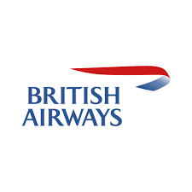

* History: British Airways was formed in 1974 following the merger of two major UK airlines, British Overseas Airways Corporation (BOAC) and British European Airways (BEA). It has a long history dating back to the early days of aviation.
* Headquarters: The airline is headquartered in Waterside, Harmondsworth, near its main hub at London Heathrow Airport.
* Fleet: British Airways has a diverse fleet of aircraft, including various models of Airbus and Boeing planes. It operates both short-haul and long-haul flights, with a range of aircraft sizes to accommodate different routes and passenger capacities.
* Destinations: British Airways serves a wide range of destinations across the globe. It operates flights to numerous cities in Europe, North America, South America, Africa, Asia, and the Middle East. Its extensive route network allows passengers to connect to various parts of the world.
* Services and Classes: British Airways offers different classes of service, including First Class, Club World (Business Class), World Traveller Plus (Premium Economy Class), and World Traveller (Economy Class). The services provided vary depending on the class, but generally, they include in-flight entertainment, meals, and a selection of beverages.
* Frequent Flyer Program: British Airways has a loyalty program called Executive Club. Passengers can earn Avios points by flying with British Airways or its partner airlines, which can be redeemed for flight upgrades, free flights, hotel stays, and other rewards.
* Oneworld Alliance: British Airways is a member of the Oneworld airline alliance. This allows passengers to enjoy benefits such as seamless travel connections, lounge access, and frequent flyer privileges when flying with other member airlines.
* Sustainability: Like many airlines, British Airways has been focusing on sustainability and reducing its environmental impact. It has implemented various initiatives, such as investing in more fuel-efficient aircraft, exploring sustainable aviation fuels, and offsetting carbon emissions.

It's important to note that while this information is accurate up to September 2021, there may have been updates or changes in British Airways' operations, fleet, or services since then.

**1.14 REFERENCE**

Help from internet following websites links have been used in the completion of this project file:

* "BRITISH AIRWAYS' SHORT-HAUL GATWICK SUBSIDIARY, BA EUROFLYER, REACHES SIGNIFICANT MILESTONE FOLLOWING RECEIPT OF AIR OPERATOR'S CERTIFICATE AND OPERATING LICENCE". *mediacentre.britishairways.com*.
* Davies, Rob (12 October 2020). "BA chief Alex Cruz steps down as airline reels from pandemic". ft.com. Archived from the original on 14 October 2020. Retrieved 12 October 2020.
* Dron, Alan (6 January 2017). "British Airways aims to mitigate strike effect". Air Transport World. Washington: Informa. Archived from the original on 12 January 2017.
* Reed, Dan. "New York-London Is The World's First Billion-Dollar Airline Route". Forbes. New York. Archived from the original on 9 July 2018. Retrieved 29 April 2019.
* "World Traveller – Preview our new Cabin". British Airways. Archived from the original on 1 September 2010. Retrieved 31 August 2010

Following books are used to have an idea about British Airways:

* Robin Higham, Speedbird: The Complete History of BOAC (London: IB Tauris, 2013) p.117
* Airliner World (Cambrian Airways – The Welsh Dragon: New routes and turboprops), Key Publishing, Stamford, UK, September 2012, p. 71
* "BA Annual Report 2018"
* "BA Annual Report 2019"
* "BA Annual Report 2020"
* Marsden, Andrew. "British Airways' Unbreakable Promise" (PDF). The Coat of Arms (222): 81–4. Archived (PDF) from the original on 27 October 2022. Retrieved 28 October 2022
* "WORLD NEWS". The Canberra Times. Vol. 49, no. 13, 923. Australian Capital Territory, Australia. 27 November 1974. p. 6. Archived from the original on 7 November 2021. Retrieved 6 November 2019 – via National Library of Australia
* Cortez, Joe (7 March 2018). "British Airways Debuts New, "Densified" Seats Without Power Outlets". FlyerTalk - The world's most popular frequent flyer community. Retrieved 27 December 2022
* Zhang, Benjamin (1 November 2018). "The 20 safest airlines in the world". Business Insider. Archived from the original on 3 January 2018. Retrieved 31 July 2019.
* Zhang, Benjamin (3 January 2019). "The 21 safest airlines in the world". Business Insider. Archived from the original on 3 January 2019. Retrieved 31 July 2019.

**1.15 BIBLIOGRAPHY**

* British Airways (1974). British Airways annual report and accounts. British Airways Board.
* Campbell-Smith, Duncan (1986). The British Airways Story: Struggle for Take-Off. Hodder and Stoughton. ISBN 978-0-340-39495-3.
* Corke, Alison (1986). British Airways: the path to profitability. Pan. ISBN 978-0-330-29570-3.
* Gregory, Martyn (1996). Dirty tricks: British Airways' secret war against Virgin Atlantic. Warner. ISBN 978-0-7515-1063-8.
* Hayward, Keith (1983). Government and British civil aerospace: a case study in post-war technology policy. Manchester University Press. ISBN 978-0-7190-0877-1.
* Marriott, Leo (1998). British Airways. Plymouth Toy & Book. ISBN 978-1-882663-39-2.
* Penrose, Harald (1980). Wings Across the World: An Illustrated History of British Airways. Cassell. ISBN 978-0-304-30697-8.
* Wood, Alan. "Airline at War: British Airways Goes to War". Air Enthusiast, No. 55, Autumn 1994, pp. 62–74. ISSN 0143-5450

**2.1 DUBAI INTERNATIONAL AIRPORT**

**Dubai International Airport** (IATA: **DXB**, ICAO: **OMDB**) is the primary international airport serving Dubai, United Arab Emirates, and is the world's busiest airport by international passenger traffic. It is also the nineteenth-busiest airport in the world by passenger traffic, one of the busiest cargo airports in the world, the busiest airport for Airbus A380 and Boeing 777 movements, and the airport with the highest average number of passengers per flight. In 2017, the airport handled 88 million passengers and 2.65 million tonnes of cargo and registered 409,493 aircraft movements.

Dubai International Airport is situated in the Al Garhoud district, 2.5 nautical miles (4.6 km; 2.9 mi) east of Dubai and spread over an area of 7,200 acres (2,900 ha) of land. Terminal 3 is the second-largest building in the world by floor space and the largest airport terminal in the world. In July 2019, Dubai International airport installed the largest solar energy system in the region's airports as part of Dubai's goal to reduce 30 percent of the city energy consumption by 2030.

Emirates Airline has its hub airport in Dubai International (DXB) and has their own terminal 3 with 3 concourses that they share with Flydubai. The Emirates hub is the largest airline hub in the Middle East; Emirates handles 51% of all passenger traffic and accounts for approximately 42% of all aircraft movements at the airport. Dubai Airport is also the base for low-cost carrier flydubai which handles 13% of passenger traffic and 25% of aircraft movements at DXB. The airport has a total capacity of 90 million passengers annually. As of January 2016, there are over 7,700 weekly flights operated by 140 airlines to over 270 destinations across all inhabited continents. Over 63% of travelers using the airport in 2018 were connecting passengers.

In 2014 Dubai International indirectly supported over 400,000 jobs and contributed over US$26.7 billion to the economy, which represented around 27% of Dubai's GDP and 21% of the employment in Dubai.

**2.2 HISTORY OF DUBAI INTERNATIONAL AIRPORT**

The history of civil aviation in Dubai started in July 1937 when an air agreement was signed for a flying boat base for the aircraft of Imperial Airways with the rental of the base at about 440 rupees per month – this included the guards' wages. The Empire Flying Boats also started operating once a week flying east to Karachi mostly direct from the UK and west to Southampton, England. By February 1938, there were four flying boats a week.

In the 1940s, flying from Dubai was by flying boats operated by British Overseas Airways Corporation (BOAC), operating the Horseshoe route from Southern Africa via the Persian Gulf to Sydney.

### **Construction**

Construction of the airport was ordered by the ruler of Dubai, Sheikh Rashid bin Saeed Al Maktoum, in 1959. It officially opened in 1960 with its first airfield, at which time it was able to handle aircraft the size of a Douglas DC-3 on a 1,800-metre-long (5,900 ft) runway made of compacted sand. Three turning-areas, an apron and small terminal completed the airport that was constructed by Costain.

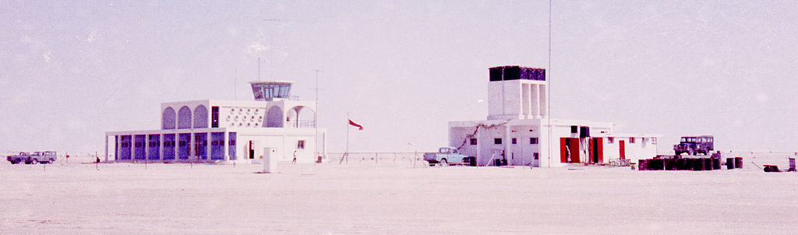

The airport's fire station and control tower seen from landside, constructed in early 1959

In May 1963, construction of a 9,200-foot (2,800 m) asphalt runway started. This new runway, alongside the original sand runway and taxiway opened in May 1965, together with several new extensions were added to the Terminal Building, hangars erected, Airport and Navigational aids were installed. The installation of the lighting system continued after the official opening and was completed in August of that year. During the second half of the 1960s several extensions, equipment upgrades like a VHF omnidirectional range (VOR) and an instrument landing system (ILS), as well as new buildings, were constructed. By 1969, the airport was served by 9 airlines serving some 20 destinations.

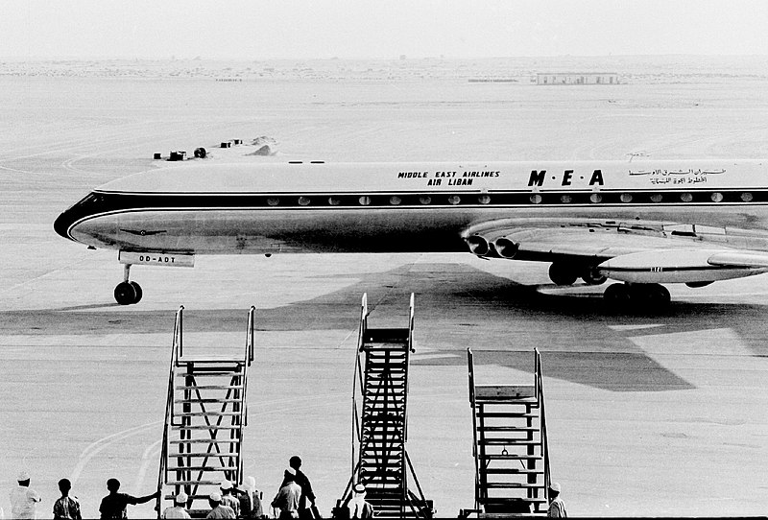

The first jet aircraft to land on the new runway at Dubai Airport in 1965 was a Comet from Middle East Airlines.

The inauguration was on 15 May 1966 and was marked by the visits of the first big jets of Middle East Airlines and Kuwait Airways Comets.

The advent of wide-body aircraft required further airport development in the 1970s, which had already been foreseen by the Ruler of Dubai, and plans for a new Terminal, runways, and taxiways capable of coping with international flights were drawn up. The construction of a new terminal building consisting of a three-storey building 110 m (360 ft) long and included an enclosed floor area of 13,400 m2 (144,000 sq ft). A new 28 m (92 ft) control tower was also constructed.

Expansion continued in the early 1970s including ILS Category II equipment, lengthening existing runway to 12,500 ft (3,810 m), installation of a non-directional beacon (NDB), diesel generators, taxiways, etc. This work made handling the Boeing 747 and Concorde possible. Several runway and apron extensions were carried out through the decade to meet growing demand.

1971 saw the new precision category 2 Approach and Runway Lighting System being commissioned. The construction of the Airport Fire Station and the installation of the generators were completed in December of that year and were fully operational in March 1972. The ruler also commissioned and inaugurated the Long-range Surveillance System on 19 June 1973.

With the expansion of the Airport Fire Services, it was necessary to find more suitable accommodation, and a hangar-style building was made available to them at the end of 1976. This was located midway between the runway ends to facilitate efficient operations. A new building was also constructed to house the Airport Maintenance Engineer, Electronics Engineering section, and Stores unit.

Expansion of the Airport Restaurant and Transit Lounge including the refurbishing of the upper level and the provision of a new kitchen was completed in December 1978.

The next phase of development was the second runway, which was completed three months ahead of schedule and opened in April 1984. This runway, located 360 m (1,180 ft) north of the existing runway and parallel to it and is equipped with the latest meteorological, airfield lighting and instrument landing systems to give the airport a Category II classification.

Also, several extensions and upgrades of terminal facilities and supporting systems were carried out. On 23 December 1980 the airport became an ordinary member of the Airports Council International (ACI). The decline of Karachi airport is often associated with the traffic Dubai took away from them.

During the 1980s, Dubai was a stopping point for airlines such as Air India, Cathay Pacific, Singapore Airlines, Malaysia Airlines, and others traveling between Asia and Europe that needed a refuelling point in the Persian Gulf. This use was later made redundant with the availability of Russian airspace due to the breakup of the Soviet Union and the advent of longer-range aircraft introduced in the late 1980s and early 1990s such as the Airbus A340, the Boeing 747-400 and the Boeing 777 series aircraft, which had the range to fly between Europe and Southeast Asia nonstop.British Airways flights from Islamabad to Manchester also stopped for short times during the 1980s.

### **Expansion**

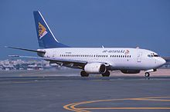

Air Astana Boeing 737-700 taxiing at Dubai International Airport in 2005

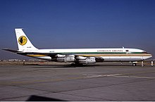

Azerbaijan Airlines Boeing 707-300 parked at a remote stand at Dubai International Airport in 1995

The opening of Terminal 2 in 1998 saw the first step of phase 1 of the new development master plan launched in 1997. As the second stage, Concourse 1 opened in April 2000 under the name of Sheikh Rashid Terminal. The concourse is 0.8 km (0.50 mi) in length and connects to the check-in area by a 0.3 km (0.19 mi) tunnel containing moving walkways (conveyor belt/travelators). It also contains a hotel, business center, health club, exchanges, dining and entertainment facilities, internet services, medical center, post office, and a prayer room. The next step was the reconfiguration of the runways, already part of phase 2, and aprons and taxiways were expanded and strengthened in 2003–2004. In addition, the Dubai Flower Centre opened in 2005 as part of the development. The airport saw the need for this as the city is a hub for import and export of flowers and the airport required a specialist facility since flowers need special conditions.

Construction of Terminal 3 began in 2004 as the next stage of phase 2 of the development, with an estimated cost of around $4.55 billion. Completion was originally planned for 2006 but was delayed by two years.

On 30 May 2008, a topping out ceremony was conducted. The terminal became operational on 14 October 2008, with Emirates Airline (EK2926) from Jeddah, Saudi Arabia, being the first flight to arrive at the new terminal and EK843 to Doha, Qatar being the first departing flight. The terminal increased the airport's maximum passenger capacity annually by 47 million, bringing the total annual capacity up to 75 million passengers.

On 29 October 2010, the airport marked its 50th anniversary. The airport has seen over 402 million passengers at an average annual growth rate of 15.5% and handled over 3.87 million aircraft at an average annual growth rate of 12.4%.

With the arrival of the Airbus A380, the airport made modifications costing $230 million. These included the building of 29 gates capable of handling the large aircraft, five of which are in Terminal 3 and two are in Terminal 1. Other important projects at the airport include the next stage of phase 2 development, which includes the construction of Concourse 3. This will be a smaller version of Concourse 2, which is connected to Terminal 3.

Also as part of the expansion, the airport is now able to handle at least 75 million (an increase of 19 million) passengers per annum with the opening of Concourse 3, which is part of Terminal 3. However, recent communications predict a further increase to 80 million passengers with additional reassessments of existing capacities. In 2009, Terminal 2 expanded its facilities to handle 5 million (an increase of 2 million) passengers annually, taking the airport's total capacity to 62 million passengers. Terminal 2 capacity was planned to be expanded to bring the total capacity of the airport from the initial 75 million passengers to 80 million passenger capacity by 2012.

The Cargo Mega Terminal, which will have the capacity to handle 3 million tonnes of cargo a year, is a major development; it is going to be built in the long term. The completion of the mega terminal will be no later than 2018. Terminal 2 will be completely redeveloped to match the status of the other two terminals. With all of these projects completed by 2013, the airport expects to be able to handle at least 75–80 million passengers and over 5 million tonnes of cargo.

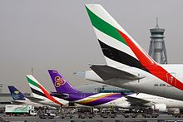

Aircraft parked at concourse C. Concourse C has a capacity of 33 million passengers.

The airport's landside facilities were modified to allow the construction of two stations for the Red Line of Dubai Metro. One station was built at Terminal 1 and the other at Terminal 3. The line began service on 9 September 2009, and opened in phases over the next year. The second Metro line, the Green Line, runs near the Airport Free Zone and has served the airport's north-eastern area with the Terminal 2 starting in September 2011.

With phase 2 of DXB's expansion plan complete, the airport now has three terminals and three concourses, two cargo mega terminals, an airport free zone, an expo center with three large exhibition halls, a major aircraft maintenance hub and a flower center to handle perishable goods. A phase 3 which has been included in the master-plan involves the construction of a new Concourse 4.

The airport revealed its future plans in May 2011, which involve the construction of a new Concourse D for all airlines currently operating from concourse C. Concourse D is expected to bring the total capacity of the airport to over 90 million passengers and will open in early 2016. The plan also involves Emirates solely operating from Concourse C along with Concourse A and B.

In September 2012, Dubai Airports changed the names of concourses to make it easier for passengers to navigate the airport. Concourse 1, in which over 100 international airlines operate, became Concourse C (C1-C50). Concourse 2 became Concourse B (B1-B32) and Concourse 3 became Concourse A (A1-A24). The gates in Terminal 2 were changed and are now numbered F1 to F12. The remaining alpha-numeric sequences are being reserved for future airport facilities that are part of the Dubai Airports' $7.8 billion expansion programme, including Concourse D.

Summary of Dubai International Airport Masterplan

|  |  |  |
| --- | --- | --- |
| **Phase** | **Year** | **Description** |
| Phase 1 | 1997 | Initial capacity of 11 million passengers per annum. $540 million phase 1 launched. |
| 1998 | Terminal 2 inaugurated on 1 May 1998, to alleviate congestion from Terminal 1, with a capacity of 2.5 million passengers annually. |
| 2000 | Sheikh Rashid Terminal (Concourse C) – reopened 15 April 2000. Capable of handling 22 million passengers per annum. |
| Phase 2 |  |  |
| 2002 | $4.5 bn ($545 m for the civils on T3 and concourse projects) launched. |
| 2003 | Taxiways were strengthened. In addition, work on other taxiways in the area was expanded in order to complete the work associated with the newly commissioned second runway. |
| 2005 | Construction of Dubai Flower Centre completed. |
| 2005 | US$225 million VIP Pavilion for the Dubai Royal Wing opens in July. |
| 2008 | Capable of handling 60 million passengers per annum with the opening of Terminal 3 – Concourse B |
| 2012 | Extensions to Terminal 2 are completed – new check-in hall, departure area, and extensions to the terminal building. |
| 2013 | New Concourse A constructed, enabling the airport to have a capacity of 80 million |
| 2016 | Concourse D will be completed with a capacity of 15 million passengers. All airlines currently operating from concourse C will move to D. |
| General Expansion | 2004–2008 | Includes construction of Emirates Flight Catering Centre, Emirates Engineering Facility. |
| 2006 | Opening of Emirates Engineering Facility – largest aircraft hangars in the world. |
| 2007 | Opening of Emirates Flight Catering Centre, capable of producing 115,000 meals per day. |
| 2008 | New Executive Flights Centre facility launched. |
| 2014 | Runway refurbishment and upgrades after an 80-day project which ran from 1 May to 20 July 2014. During this period, DXB operated with one single runway. New LED lighting replaced the old tungsten runway lights and new taxiways were constructed enabling an increase in runway capacity. |
| 2015 | Terminal 2 capacity increased to 10 million after expansion completed. |

Dubai's government announced the construction of a new airport in Jebel Ali, named Dubai World Central – Al Maktoum International Airport. It is expected to be the second-largest airport in the world by physical size, though not by passenger metrics. It opened 27 June 2010; however, construction is not expected to finish until 2027. The airport is expected to be able to accommodate up to 160 million passengers. There has been an official plan to build the Dubai Metro Purple Line to connect Al Maktoum International Airport to Dubai International Airport; construction was set to begin in 2012. The proposed 52 km (32 mi) Purple Line will link Dubai International Airport and Al Maktoum International Airport.

Concourse D opened on 24 February 2016 for all international airlines and moved out of the Terminal 1. Emirates now operates from Concourses A, B and C, all under Terminal 3. while FlyDubai operates from Terminal 2 (Concourse F).

Growth in traffic at Dubai International Airport

|  |  |  |  |  |  |  |  |
| --- | --- | --- | --- | --- | --- | --- | --- |
| **Airlines** | **1990** | **1994** | **1998** | **2002** | **2006** | **2010** | **2014** |
| Passenger movements | 4.347 million | 6.299 million | 9.732 million | 15.973 million | 28.788 million | 47.181 million | 70.476 million |
| Airfreight movements (tonnes) | 144,282 | 243,092 | 431,777 | 764,193 | 1.410 million | 2.19 million | 2.37 million |
| City links | 36 | 54 | 110 | 170 | 195 | 210 | 240 |
| Weekly scheduled flights | N/A | N/A | 2,350 | 2,850 | 4,550 | 6,100 | 7,500 |
| Airlines | N/A | N/A | 80 | 102 | 113 | 135 | 140 |

On 20 December 2018 the airport celebrated its one billionth passenger.

## **2.3 AIR TRAFFIC**

### **Main airlines based at DXB**

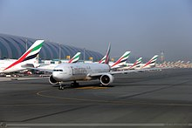

Emirates operations at Dubai International

* **Emirates Airline** is the largest airline operating at the airport, with an all-wide-body fleet of over 200 Airbus and Boeing aircraft based at Dubai, providing scheduled services to the Middle East, Africa, Asia, Europe, North America, South America, Australia and New Zealand. It operates out of Terminal 3, Concourses A, B and C.
* **Emirates SkyCargo**, a subsidiary of Emirates, operates scheduled all-cargo services between Dubai and the rest of the world.
* **Flydubai**, a low-cost airline planning to operate over 100 aircraft on scheduled passenger services to and from Dubai, to the Middle East, Africa, Europe and South Asia. It operates from Terminal 2 and, since December 2018, also from Terminal 3 for selected destinations.

Recreational flying to Dubai is catered for by the Dubai Aviation Club, which undertakes flying training for private pilots and provides facilities for private owners.

The Government of Dubai provides short- and long-range search and rescue services, police support, medical evacuation and general-purpose flights for the airport and all VIP flights to the airport.

## **Statistics**

Operations and statistics

|  |  |  |  |
| --- | --- | --- | --- |
|  |  |  |  |
| **Year** | **Passengers** | **Airfreight (tonnes)** | **Aircraft** |
| 2003 | 18,062,344 | 928,758 | 148,334 |
| 2004 | 21,711,883 | 1,111,647 | 168,511 |
| 2005 | 23,607,507 | 1,333,014 | 195,820 |
| 2006 | 28,788,726 | 1,410,963 | 217,165 |
| 2007 | 34,340,000 | 1,668,505 | 260,530 |
| 2008 | 37,441,440 | 1,824,991 |  |
| 2009 | 40,901,752 | 1,927,520 |  |
| 2010 | 47,180,628 | 2,270,498 | 292,662 |
| 2011 | 50,977,960 | 2,199,750 | 326,317 |
| 2012 | 57,684,550 | 2,279,624 | 344,245 |
| 2013 | 66,431,533 | 2,435,567 | 369,953 |
| 2014 | 70,475,636 | 2,367,574 | 357,339 |
| 2015 | 78,014,841 | 2,506,092 | 406,625 |
| 2016 | 83,654,250 | 2,592,454 | 418,220 |
| 2017 | 88,242,099 |  |  |
| 2018 | 89,149,387 |  |  |
| 2019 | 86,396,757 |  |  |
| 2020 | 18,229,461 |  |  |
| 2021 | 29,110,609 |  |  |
| 2022 | 66,069,981 |  |  |

**2.4 INFRASTRUCTURE**

Dubai International Airport was conceptualized to function as Dubai's primary airport and the region's busiest for the foreseeable future without the need for relocation or the building of another airport when passenger figures increased. The area was chosen near to Dubai, to attract passengers from the city of Dubai, rather than travel to the busier Sharjah International Airport. The planned location originally was Jebel Ali.

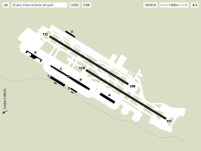

Airport layout

The original master plan for the existing airport initially involved a dual-terminal and one runway configuration over two phases with provisions for another two passenger terminals in the near future. Phase 1 included the construction for the first passenger terminal, the first runway, 70 aircraft parking bays, support facilities and structures, including large maintenance hangar, the first fire station, workshops, and administrative offices, an airfreight complex, two cargo agents' buildings, in-flight catering kitchens and an 87 m (285 ft) control tower. Construction for the second phase would commence immediately after the completion of Phase 1 and include the second runway, 50 new aircraft parking bays in addition to the existing 70 bays, a second fire station and a third cargo agent building.

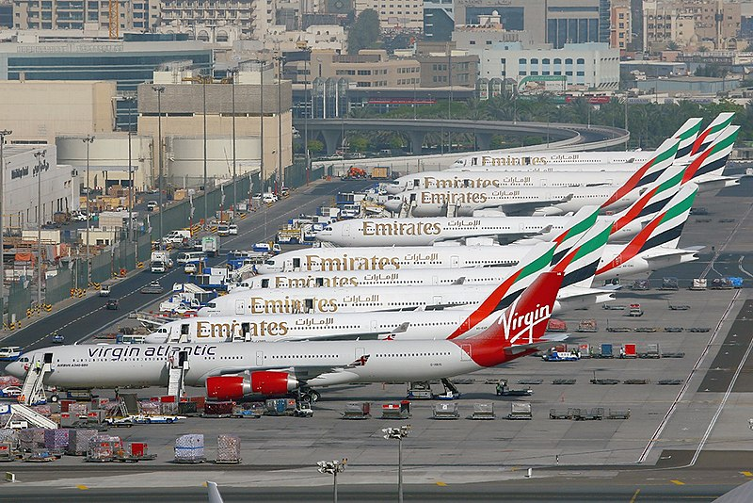

Aircraft parked at remote stands at DXB

The third phase included the construction of a new terminal (now the parts of Terminal 1's main building and Concourse C) and an additional 60 parking bays, as well as a new aircraft maintenance facility. Then, in the early 2000s (decade) a new master plan was introduced which began the development of the current concourses and terminal infrastructure.

Paul Griffiths (Dubai Airports' CEO) in his interview to *Vision* magazine, cited plans to build infrastructure to support the expansion of Emirates and budget airline flydubai, and ascend the ranks of global aviation hubs

### **Control tower**

The 87-metre-tall (285 ft) airport traffic control tower (ATCT) was constructed as part of phase two of the then development plan.

### **Terminals**

Dubai International Airport has three terminals. Terminal 1 has one concourse (concourse D), Terminal 2 is set apart from the other two main buildings and Terminal 3 is divided into Concourse A, B, and C. The cargo terminal is capable of handling 3 million tonnes of cargo annually and a general aviation terminal (GAT) is close by

### **Passenger terminals**

Dubai Airport has three passenger terminals. Terminals 1 and 3 are directly connected with a common transit area, with airside passengers being able to move freely between the terminals without going through immigration, while Terminal 2 is on the opposite side of the airport. For transiting passengers, a shuttle service runs between the terminals, with a journey time of around 20 minutes from Terminal 2 to Terminal 1 and 30 minutes to Terminal 3. Passengers in Terminal 3 who need to transfer between concourse A and the rest of the Terminal have to travel via an automated people mover. Also after early 2016 when the construction of Concourse D was done, there is now an automated people mover between concourse D and Terminal 1.

Situated beside Terminal 2 is the Executive Flights Terminal, which has its own check in facilities for premium passengers and where transportation to aircraft in any of the other terminals is by personal buggy.

The three passenger terminals have a total handling capacity of around 80 million passengers a year.

Terminals 1 and 3 cater to international passengers, whilst Terminal 2 is for budget passengers and passengers flying to the subcontinent and Persian Gulf region; Terminals 1 and 3 handle 85% of the passenger traffic and the Executive Flights terminal is for the higher-end travelers and important guests.

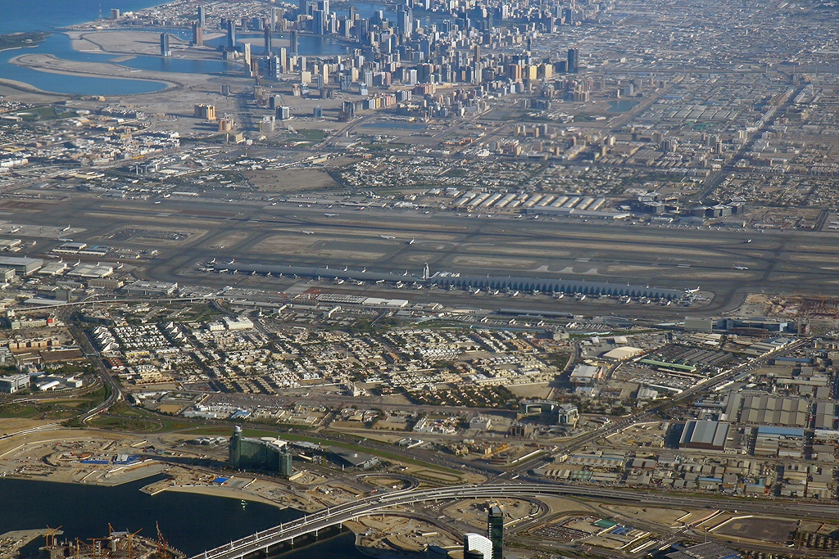

Aerial view of concourse B and C. Concourse A (not shown) is connected to Terminal 3 via Terminal 3 APM. Concourse D is also connected to Terminal 1 via Terminal 1 APM.

#### **Terminal 1**

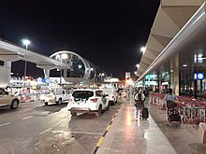

Outside DXB Terminal 1

Terminal 1 has a capacity of 45 million passengers. It is used by over 100 airlines and is connected to Concourse D by an automated people mover. It is spread over an area of 520,000 m2 (5,600,000 sq ft) and offers 221 check-in counters.

The Terminal was originally built to handle 18 million passengers; however, with extreme congestion at the terminal, the airport was forced to expand the terminal to accommodate the opening of 28 remote gates. Over the years, more mobile gates were added to the airport bringing the total as of 2010 to 28.

In 2013, Dubai Airports announced a major renovation for Terminal 1 and Concourse C. The renovations include upgraded baggage systems, replacement of check-in desks and a more spacious departure hall. Arrivals will also see improvements to help reduce waiting times. The renovation was completed by the middle of 2015.

**Concourse D**

Planning began for further expansion of Dubai Airport, with the construction of Terminal 4, it was revealed on the day Emirates completed its phased operations at the new Terminal 3, on 14 November 2008. According to Dubai Airport officials, plans for Terminal 4 had begun and extensions would be made to Terminal 3. These are required to bring the capacity of the airport to 80–90 million passengers a year by 2015.

In May 2011, Paul Griffiths, chief executive of Dubai Airports revealed the Dubai Airport masterplan. It involves the construction of Concourse D (previously Terminal 4). With a capacity of 15 million, it would bring the total capacity of the airport to 90 million passengers by 2018—an increase of 15 million. It also will see Emirates take over the operation at Concourse C, along with concourse A and B which it will already be operating. All remaining airlines will shift to Concourse D, or move to Al Maktoum International Airport. The airport projects that international passenger and cargo traffic will increase at an average annual growth rate of 7.2% and 6.7%, respectively, and that by 2020 passenger numbers at Dubai International Airport will reach 98.5 million and cargo volumes will top 4.1 million tonnes.

Concourse D will have a capacity of 15 million passengers, include 17 gates and will be connected to Terminal 1 via an automated people mover. On 6 February 2016, members of the public were invited to trial the concourse in preparation for its opening. On Wednesday, 24 February 2016, Concourse D officially opened with the first British Airways flight arriving at gate D8.

Concourse D and Terminal 1 reopened on 24 June 2021 following a year's closure due to the COVID-19 pandemic.

#### **Terminal 2**

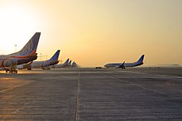

FlyDubai aircraft parked at Terminal 2 aircraft stands

Terminal 2 built in 1998 has an area of 47,000 m2 (510,000 sq ft) and has a capacity of 10 million as of 2013, after several, decent reconstructions and a major expansion in 2012 which saw capacity double. It is used by over 50 airlines, mainly operating in the Persian Gulf region. Most flights operate to India, Saudi Arabia, Iran, Afghanistan and Pakistan.

In June 2009, Terminal 2 became the hub of Air India Express and flydubai, and the terminal houses the airline's corporate head office.

Terminal 2 has undergone a major refurbishment recently, extending check-in and boarding facilities, changing the interior and exterior décor, and offering more dining choices to passengers. Capacity was increased to allow for 10 million passengers, an increase of 5 million.

The terminal has now increased the number of facilities available to passengers. Check-in counters have increased to 37. The boarding area is more spacious, with more natural light. Also the new open boarding gates allow several flights to board simultaneously, improving passenger and aircraft movements. There are a total of 43 remote stands at the terminal. However, passengers cannot move between Terminal 2 to 1 or from 2 to 3 and vice versa inside the airport. They have to make use of Taxi service or public transport available outside.

The Dubai duty-free shopping area covers 2,400 m2 (26,000 sq ft) in departures and 540 m2 (5,800 sq ft) in arrivals. The 3,600-square-metre (39,000 sq ft) extension included a larger arrivals hall as well.

Terminal 2 has no jetbridges and so passengers are bussed to the aircraft at gates F1-F12

#### **Terminal 3**

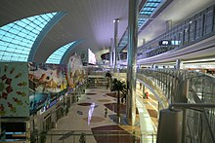

Interior of Terminal 3

The partly underground Terminal 3 was built at a cost of US$4.5 billion, exclusively for Emirates and has a capacity of 65 million passengers. The terminal has 20 Airbus A380 gates at Concourse A and 5 at Concourse B and 2 at Concourse C. It was announced on 6 September 2012 that Terminal 3 would no longer be Emirates-exclusive, as Emirates and Qantas had set up an extensive code sharing agreement. Qantas would be the second and only one of two airlines to fly in and out of Terminal 3. This deal also allows Qantas to use the A380 dedicated concourse.

Upon completion, Terminal 3 was the largest building in the world by floor space, with over 1,713,000 m2 (18,440,000 sq ft) of space, capable of handling 60 million passengers in a year. A large part is located under the taxiway area and is directly connected to Concourse B: the departure and arrival halls in the new structure are 10 m (33 ft) beneath the airport's apron. Concourse A is connected to the terminal via a Terminal 3 APM. It has been operational since 14 October 2008, and opened in four phases to avoid collapse of baggage handling and other IT systems.

The building includes a multi level underground structure, first and business class lounges, restaurants, 180 check-in counters and 2,600 car-parking spaces. The terminal offers more than double the previous retail area of concourse C, by adding about 4,800 m2 (52,000 sq ft) and Concourse B's 10,700 m2 (115,000 sq ft) of shopping facilities.

In arrivals, the terminal contains 72 immigration counters and 14 baggage carousels. The baggage handling system—the largest system and also the deepest in the world—has a capacity to handle 8,000 bags per hour. The system includes 21 screening injection points, 49 make-up carousels, 90 km (56 mi) of conveyor belts capable of handling 15,000 items per hour at a speed of 27 km/h (17 mph) and 4,500 early baggage storage positions.

##### Concourse A

Concourse A, part of Terminal 3, opened 2 January 2013, has a capacity of 19 million passengers and is connected to the two major public levels of Terminal 3 via Terminal 3 APM in addition to the vehicular and baggage handling system utility tunnels for further transfer. The concourse opened on 2 January 2013 and was built at a cost of US$3.3 billion. The building, which follows the characteristic shape of Concourse B, 924 m (3,031 ft) long, 91 m (299 ft) wide and 40 m (130 ft) high in the centre from the apron level and accommodates 20 air bridge gates, of which all are capable of handling the Airbus A380-800. There are also 6 remote lounges for passengers departing on flights parked at 13 remote stands. The gates in concourse A are labelled A1–A24. Gates A6, A7, A18 and A19 are not equipped with jetbridges and so passengers departing from these gates are bussed to the aircraft.

The concourse includes one 4-star hotel and one 5-star hotel, first- and business-class lounges, and duty-free areas. The total built-up area is 540,000 m2 (5,800,000 sq ft). The concourse allows for multi-level boarding and boasts the largest first and business class lounges in the world. Each lounge has its own dedicated floor offering direct aircraft access from the lounges. The total amount of retail space at the concourse is 11,000 m2 (120,000 sq ft), and there is also a total of 14 cafes and restaurants.

The total retail area in the concourse is approximately 11,000 m2 (120,000 sq ft).

##### **Concourse B**

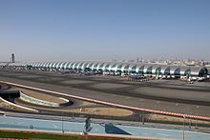

Exterior of Concourse B

Concourse B is directly connected to terminal 3 and is dedicated exclusively to Emirates. The total built up area of the concourse itself is 675,000 m2 (7,270,000 sq ft). The concourse is 945 m (3,100 ft) long, 90.8 m (298 ft) wide (at midpoint) and 49.5 m (162 ft) high. The terminal has 10 floors (4 basements, a ground floor and 5 above floors). The building currently includes a multi-level structure for departures and arrivals and includes 32 gates, labelled B1–B32. The concourse has 26 air bridge gates (gates B7-B32) and 5 boarding lounges (B1-B6) for 14 remote stands that are for Airbus A340 and Boeing 777 aircraft only. For transit passengers the concourse has 3 transfer areas and 62 transfer desks.

The concourse also includes the Emirates first and Business class lounges, and the Marhaba lounge. The First class lounge has a capacity of 1,800 passengers and a total area of 12,600 m2 (136,000 sq ft). The Business class lounge has a capacity of 3,000 passengers and a total area of 13,500 m2 (145,000 sq ft). The Marhaba lounge, the smallest lounge at the concourse has a capacity of 300 passengers at a time.

The total retail area at the concourse is 120,000 m2 (1,300,000 sq ft), which also includes 18 restaurants within the food court. There are also three hotels in the concourse; a 5-star hotel and a 4-star hotel.

There is a direct connection to Sheikh Rashid Terminal (Concourse C) located at the control tower structure through passenger walkways. There is also a 300-room hotel and health club including both five and four star rooms. Concourse B includes five aerobridges that are capable of handling the new Airbus A380. Emirates Airline continues to maintain a presence in Concourse C, operating 12 gates at the concourse as well as the Emirates First Class and Business Class Lounges.

##### Concourse C

Concourse C, is a part of Terminal 3, was opened in 2000 and used to be the largest concourse at Dubai International Airport before Concourse B in Terminal 3 opened. It incorporates 50 gates, including 28 air bridges at gates (C1-C23, except for C12a, C15 and C15a) and 22 remote gates located at a lower level of the terminal at gates C29-C50. The gates are labelled C1–C50.

The concourse includes over 17 food and beverage cafes and restaurants, with the food court being located on the Departures Level. Also located in the concourse is a 5-star hotel and a 5,400 m2 (58,000 sq ft) duty-free shopping facility. Other facilities include prayer rooms and a medical centre. Concourse C became part of Terminal 3 in 2016 after concourse D opened.

#### **Al Majlis VIP Pavilion and Dubai Executive Flight Terminal**

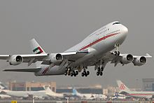

Dubai Royal Air Wing is the main airline operating from the VIP Pavilion.

The Al Majlis VIP pavilion was exclusively built for the Dubai Royal Air Wing and opened on 1 July 2008. The entire facility is a 3,400-square-metre (37,000 sq ft) terminal, and includes a Royal Majlis and an antenna farm. It also includes eight aircraft hangars with a total built up area of 69,598 m2 (749,150 sq ft) and maintenance hangars for Boeing 747s and Airbus A380s, and a 1,200-square-metre (13,000 sq ft) gatehouse for VIP service. In 2010 there were 47,213 customers, 13,162 movements and in 2009, there were a total of 43,968 customers and 14,896 movements.

Executive Flight Services (EFS) caters to those passengers of high class or special importance that travel through Dubai International Airports. It is the largest dedicated business aviation terminal of its kind in the Middle East. It is located at the Dubai Airport Free Zone close to Dubai International's Terminal 2. It only caters to private flights exclusive to the terminal. Airlines operating from the terminal are expected to maintain a lounge. In 2010, EFS handled 7,889 aircraft movements and 25,177 passengers.

The centre itself is located close to Terminal 2, and includes a 5,500 m2 (59,000 sq ft) two-storey main building, a 3,700 m2 (40,000 sq ft) hangar, a 3,700 m2 (40,000 sq ft) ramp area for aircraft parking and a special VIP car park for long term parking. The centre also has its own immigration and customs sections, its own Dubai Duty Free outlet, a fully equipped business and conference centre, eight luxury private lounges and a limousine service between aircraft and the terminal. The ramp area of the terminal can accommodate up to 22 small-sized private jets, between 8 and 12 medium-sized jets or up to four large-sized jets such as a Boeing Business Jet (BBJ), the Boeing 727 or the Airbus A319. The facility makes EFC the largest dedicated business aviation terminal in the Middle East.

#### **Cargo Mega Terminal**

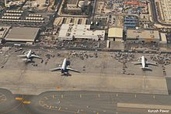

Aircraft stands at the cargo terminal

The cargo village at Dubai International Airport is one of the world's largest and most central cargo hubs, with most of the cargo for Asia and Africa coming through the facility. Forecasts in 2004 for cargo growth predicted that additional major cargo handling facilities were needed to satisfy demands. Plans were put in place to construct the first stage of the cargo mega terminal, which by 2018 will have the ability to handle three million tons of freight. Phase 1 of the cargo mega terminal was completed by 2004 and the next phase of expansion was scheduled for completion in late 2007. Presently the airport has a cargo capacity of 2.5 million tonnes, and will be expanded to handle 3 million.

#### **Flower centre**

Dubai Airport has constructed a flower centre to handle flower imports and exports, as Dubai is a major hub for the import and export of flowers, and the airport required a specialist facility since these products need special conditions. The flower centre's first phase was completed in 2004 at a cost of $50 million.

The centre when completed and functioning will have a floor area of approximately 100,000 m2 (1,100,000 sq ft) including different export chambers and offices. The handling capacity of the centre is expected to be more than 300,000 tonnes of product throughput per annum. The entire facility (with the exception of the offices) will be maintained at an ambient temperature of just 2 to 4 °C (36 to 39 °F).

### **Runways**

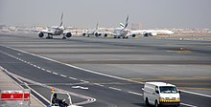

Aircraft taxiing to runway 12L/30R

Dubai Airport has two closely spaced parallel runways, 12R/30L is 4,447 m × 60 m (14,590 ft × 197 ft), 12L/30R is 4,000 m × 60 m (13,120 ft × 200 ft). The gap between the centrelines of the two runways is 385 m (1,263 ft). The runways are equipped with four sets of ILSS to guide landing aircraft safely under very poor weather conditions. The runways were expanded to accommodate the Airbus A380 which came into service in 2007. In 2009, it was announced that the airport installed a Category III landing system, allowing planes to land in low-visibility conditions, such as fog. This system was the first of its kind in the United Arab Emirates.

In 2013 Dubai Airports announced an 80-day runway refurbishment program which started on 1 May 2014 and was completed on 21 July 2014. The northern runway was resurfaced while lighting upgrades and additional taxiways were built on the southern runway to help boost its capacity. The southern runway was closed from 1 to 31 May 2014, while the northern runway was closed from 31 May to 20 July 2014. Due to extra congestion on one runway, all freighter, charter and general aviation flights were diverted to Al Maktoum International Airport. Flights at DXB were reduced by 26% and 14 airlines moved to Al Maktoum International Airport whilst the runways works were being done. Emirates cut 5,000 flights and grounded over 20 aircraft during the period.

Dubai Airports plans to close the southern runway (12R/30L) for complete resurfacing and replacement of the airfield lighting and supporting infrastructure. This will be done during a 45-day period from 16 April 2019 to 30 May 2019. This upgrade will boost safety, service and capacity levels at DXB. Airlines will be required to reduce flight operations at DXB due to single runway operations.

### **Accommodating the Airbus A380**

With Dubai-based Emirates being one of the launch customers for the Airbus A380 and also the largest customer, Dubai Airport needed to expand its existing facilities to accommodate the very large aircraft. The Department of Civil Aviation spent $120 million in upgrading both of its terminals and airport infrastructure, including enlarged gate holdrooms, new finger piers, an enlarged runway, new airbridges and extended baggage belt carousels from the normal 70 to 90 m (230 to 300 ft). Dubai Airport also invested $3.5 billion into a new Concourse A, exclusively for handling Emirates A380s. With the changes made, the airport does not expect embarking and disembarking passengers and baggage from the A380 to take longer than it does for Boeing 747-400s, which carry fewer passengers. On 16 July 2008, Dubai Airport unveiled the first of two specially-built gates capable of handling the aircraft. Costing $10 million, the gates will enable passengers to get on the upper cabin of the new 555-seater aircraft directly from the gate hold rooms. The hold rooms themselves have been enlarged to cater for the larger number of passengers flying the A380s. In addition to the two gates at Terminal 1, five more A380-capable gates were opened at concourse B on 14 October 2008. Concourse A opened on 2 January 2013.

## **Labor controversy**

Workers building a new terminal at Dubai International Airport went on a sympathy strike in March 2006. Another strike took place in October 2007. Four thousand strikers were arrested. Most of them were released some days later and those who were not local were then deported from Dubai.

**2.4 AIRLINES AND DESTINATION**

### **Passenger**

The following airlines offer regular scheduled and charter services to and from the airport:

|  |  |
| --- | --- |
| **Airlines** | **Destinations** |
| Aeroflot | Moscow–Sheremetyevo |
| Air Algérie | Algiers |
| Air Astana | Almaty, Astana |
| Air Canada | Toronto–Pearson, Vancouver (begins 30 October 2023) |
| Air China | Beijing–Capital, Chongqing |
| Air France | Paris–Charles de Gaulle |
| Air India | Chennai, Delhi, Goa–Dabolim, Hyderabad, Kochi, Mumbai |
| Air India Express | Amritsar, Goa–Dabolim, Indore, Jaipur, Kannur, Kochi, Kozhikode, Lucknow, Mangalore,Thiruvananthapuram, Tiruchirappalli |
| Air Peace | Abuja, Lagos |
| airBaltic | Riga**Seasonal:** Vilnius (begins 1 November 2023) |
| airblue | Islamabad, Karachi, Lahore, Multan, Peshawar |
| Anadolu Jet | Istanbul–Sabiha Gökçen |
| Ariana Afghan Airlines | Kabul |
| Arkia | Tel Aviv |
| Azerbaijan Airlines | Baku |
| Azimuth | Rostov-on-Don (suspended) |
| Azur Air | Moscow–Vnukovo (suspended) |
| Azur Air Ukraine | **Seasonal charter:** Kyiv–Boryspil (suspended) |
| Badr Airlines | Khartoum |
| Belavia | Minsk |
| Biman Bangladesh Airlines | Chittagong, Dhaka, Sylhet |
| British Airways | London–Heathrow |
| Cathay Pacific | Hong Kong |
| Cebu Pacific | Manila |
| China Eastern Airlines | Kunming, Qingdao, Shanghai–Pudong |
| China Southern Airlines | Guangzhou, Shenzhen,Wuhan (begins 29 June 2023) |
| Cyprus Airways | Larnaca |
| Daallo Airlines | Hargeisa, Mogadishu |
| Egyptair | Alexandria, Cairo |
| El Al | Tel Aviv |
| Emirates | Abidjan, Abuja, Accra, Addis Ababa, Ahmedabad, Algiers, Amman–Queen Alia, Amsterdam, Athens, Auckland, Baghdad, Bahrain, Bangalore, Bangkok–Suvarnabhumi, Barcelona, Basra, Beijing–Capital, Beirut, Birmingham, Bologna, Boston, Brisbane, Brussels, Budapest, Buenos Aires–Ezeiza, Cairo, Cape Town, Casablanca, Cebu, Chennai, Chicago–O'Hare, Christchurch, Clark, Colombo–Bandaranaike, Conakry, Copenhagen, Dakar–Diass, Dallas/Fort Worth, Dammam, Dar es Salaam, Delhi, Denpasar, Dhaka, Dublin, Durban, Dϋsseldorf, Entebbe, Erbil, Frankfurt, Geneva, Glasgow, Guangzhou, Hamburg, Hanoi, Harare, Ho Chi Minh City, Hong Kong, Houston–Intercontinental, Hyderabad, Islamabad, Istanbul, Istanbul–Sabiha Gökçen,Jakarta–Soekarno-Hatta, Jeddah, Johannesburg–O. R. Tambo, Kabul (suspended), Karachi, Khartoum, Kochi, Kolkata, Kuala Lumpur–International, Kuwait City, Lagos, Lahore, Larnaca, Lisbon, London–Gatwick, London–Heathrow, London–Stansted, Los Angeles, Luanda, Lusaka, Lyon, Madrid, Mahé, Malé, Malta, Manchester, Manila, Mauritius, Medina, Melbourne, Mexico City, Miami, Milan–Malpensa, Montréal–Trudeau (begins 5 July 2023), Moscow–Domodedovo, Mumbai, Munich, Muscat, Nairobi–Jomo Kenyatta, Newark, Newcastle upon Tyne, New York–JFK, Nice, Orlando, Osaka–Kansai, Oslo, Paris–Charles de Gaulle, Perth, Peshawar, Phuket, Prague, Riyadh, Rio de Janeiro–Galeão, Rome–Fiumicino, Salalah, San Francisco, São Paulo–Guarulhos, Saint Petersburg, Seattle/Tacoma, Seoul–Incheon, Shanghai–Pudong, Sialkot, Singapore, Stockholm–Arlanda, Sydney, Taipei–Taoyuan, Tehran–Imam Khomeini, Tel Aviv, Thiruvananthapuram, Tokyo–Haneda,Tokyo–Narita, Toronto–Pearson, Tunis, Venice, Vienna, Warsaw–Chopin, Washington–Dulles, Zürich |
| Enter Air | **Seasonal:** Warsaw–Chopin |
| Ethiopian Airlines | Addis Ababa |
| Eurowings | Berlin, Stuttgart (both begin 29 October 2023) |
| Finnair | **Seasonal:** Helsinki |
| FitsAir | Colombo–Bandaranaike |
| Flyadeal | Riyadh |
| FlyArystan | Aktau, Aktobe, Oral, Shymkent |
| Fly Baghdad | Baghdad |
| flydubai | Abha, Addis Ababa, Ahmedabad, Alexandria, Almaty, Al Qaisumah, Al Ula, Amman–Queen Alia, Ankara,Ashgabat, Asmara, Astana, Baghdad, Bahrain, Baku, Bandar Abbas, Basra, Beirut, Belgrade, Bergamo, Bishkek, Bucharest–Otopeni, Budapest, Catania, Chennai, Chittagong, Colombo–Bandaranaike, Dammam, Dar es Salaam, Delhi, Dhaka, Djibouti, Doha, Dushanbe, Entebbe, Erbil, Faisalabad, Gassim, Grozny, Ha'il, Hargeisa, Helsinki, Hofuf, Hyderabad, Isfahan, Istanbul–Sabiha Gökçen, Jeddah, Jizan, Juba, Kabul (suspended), Karachi, Kathmandu, Kazan, Khartoum, Kilimanjaro, Kochi, Kolkata, Kozhikode, Krabi, Kraków, Krasnodar, Kuwait City, Kyiv–Boryspil (suspended), Lar, Ljubljana, Lucknow, Makhachkala, Malé, Mashhad, Medina, Mogadishu, Moscow–Vnukovo, Moscow–Zhukovsky, Mineralnye Vody, Multan, Mumbai, Muscat, Najaf, Najran, Namangan, Naples, Neom Bay, Novosibirsk, Odesa (suspended), Pattaya–U-Tapao, Perm, Pisa, Port Sudan, Poznań (begins 29 October 2023), Prague, Quetta, Riyadh, Saint Petersburg, Salalah, Salzburg, Samara, Samarkand, Sarajevo, Shiraz, Shymkent, Sialkot, Sochi, Sofia, Sohag, Sohar, Sulaimaniyah, Tabuk, Ta'if, Tashkent, Tbilisi, Tehran–Imam Khomeini, Tel Aviv, Tirana, Ufa, Warsaw–Chopin, Yangon, Yekaterinburg, Yerevan, Zagreb, Zanzibar **Seasonal:** Batumi, Bodrum, Cagliari (begins 22 June 2023), Corfu (begins 24 June 2023), Dubrovnik, İzmir, Kazan, Kutaisi, Makhachkala, Mineralnye Vody,Mykonos, Rostov-on-Don, Samara,Qabala, Santorini, Tivat, Trabzon |
| Flynas | Dammam, Jeddah, Riyadh |
| FlyOne | Chișinău (begins 1 November 2023) |
| FLYONE Armenia | Yerevan |
| Go First | Kannur |
| Gulf Air | Bahrain |
| IndiGo | Ahmedabad, Amritsar, Bangalore, Bhubaneswar, Chandigarh, Chennai, Delhi, Hyderabad, Kochi, Kozhikode, Lucknow (resumes 11 July 2023), Mangalore, Mumbai, Thiruvananthapuram, Tiruchirappalli |
| Iran Air | Ahvaz, Bandar Abbas, Lar, Shiraz |
| Iran Airtour | Mashhad, Tehran–Imam Khomeini |
| Iraqi Airways | Baghdad, Basra, Erbil, Najaf |
| Israir | Tel Aviv |
| Jazeera Airways | Kuwait City |
| Jordan Aviation | Amman–Queen Alia |
| Jubba Airways | Bosaso, Hargeisa, Mogadishu |
| Kam Air | Kabul |
| Karun Airlines | Ahvaz |
| Kenya Airways | Mombasa, Nairobi–Jomo Kenyatta |
| KLM | Amsterdam |
| Korean Air | Seoul–Incheon |
| Kuwait Airways | Kuwait City |
| LOT Polish Airlines | **Seasonal:** Warsaw–Chopin |
| Lufthansa | Frankfurt, Munich |
| Luxair | **Seasonal:** Luxembourg |
| Mahan Air | Tehran–Imam Khomeini |
| Middle East Airlines | Beirut |
| Myanmar Airways International | Yangon |
| Nepal Airlines | Kathmandu |
| Oman Air | Muscat |
| Pakistan International Airlines | Faisalabad, Islamabad, Karachi, Lahore, Multan, Peshawar, Sialkot |
| Pegasus Airlines | Ankara, Istanbul–Sabiha Gökçen |
| Philippine Airlines | Manila |
| Qatar Airways | Doha |
| Qeshm Air | Bandar Abbas, Lar, Qeshm, Shiraz, Tehran–Imam Khomeini |
| Rossiya Airlines | **Seasonal charter:** Moscow–Vnukovo (suspended) |
| Royal Air Maroc | Casablanca |
| Royal Brunei Airlines | Bandar Seri Begawan, London–Heathrow |
| Royal Jordanian | Amman–Queen Alia |
| RwandAir | Kigali |
| S7 Airlines | **Seasonal:** Novosibirsk (suspended) |
| Saudia | Jeddah, Neom Bay, Riyadh |
| SereneAir | Islamabad, Lahore, Peshawar |
| Sichuan Airlines | Chengdu–Tianfu |
| Singapore Airlines | Singapore |
| SkyUp | Kyiv–Boryspil (temporarily suspended) |
| Smartwings | Bratislava, Ostrava, Prague |
| Somon Air | Dushanbe |
| SpiceJet | Ahmedabad, Amritsar, Delhi, Jaipur, Kochi, Kozhikode, Madurai, Mumbai, Pune |
| SriLankan Airlines | Colombo–Bandaranaike |
| SunExpress | Antalya **Seasonal:** İzmir |
| Swiss International Air Lines | Zürich |
| Syrian Air | Damascus, Latakia |
| Transavia | **Seasonal:** Amsterdam |
| Turkish Airlines | Istanbul |
| Turkmenistan Airlines | Ashgabat |
| Uganda Airlines | Entebbe |
| United Airlines | Newark |
| Ukraine International Airlines | Kyiv–Boryspil |
| Ural Airlines | Chelyabinsk, Yekaterinburg **Seasonal:** Moscow–Domodedovo, Samara |
| US-Bangla Airlines | Dhaka |
| Uzbekistan Airways | Fergana, Tashkent |
| Vistara | Mumbai |
| Wizz Air | **Seasonal:** Bucharest–Otopeni, Budapest, Sofia |
| Yamal Airlines | **Seasonal:** Tyumen |

**2.5 CARGO**

The airport handled 2.37 million tonnes of air cargo in 2014, a decrease of 3.1 per cent over 2013, making it the sixth-busiest airfreight hub in the world and the busiest in the Middle East. The decline was due to the runway closure, and the shifting of many cargo flights from DXB to Al Maktoum International Airport.

|  |  |
| --- | --- |
| **Airlines** | **Destinations** |
| Cargolux | Hong Kong, Komatsu, Luxembourg |
| DHL Aviation | Bahrain |
| Coyne Airways | Baghdad, Bagram, Erbil, Kabul, Kandahar |
| Egyptair Cargo | Cairo |
| Ethiopian Cargo | Addis Ababa |
| FedEx Express | Athens, Bangalore, Chengdu–Shuangliu, Delhi, Goa, Hong Kong, Johannesburg, Milan–Malpensa, Mumbai, Nairobi–Jomo Kenyatta, Paris–Charles de Gaulle, Singapore |
| FitsAir | Abu Dhabi, Baghdad, Balad, Colombo–Bandaranaike, Erbil, Herat, Jalalabad, Kabul, Kandahar, Lashkar Gah, Sharana, Sulaymaniyah, Tarin Kowt, Thumrait |
| Silk Way Airlines | Baku |
| UPS Airlines | Bangkok–Suvarnabhumi, Clark, Cologne/Bonn, Delhi, Guangzhou, Hong Kong, Louisville, Singapore, Sydney |

**2.6 OPERATIONS**

Since there are international flights operating out from the airport, the terminals are equipped with immigration processing facilities and security scanning for all passengers including domestic, and regional passengers. Terminals 1 and 3 handle 95% of the international flights, whilst Terminal 2 mainly caters to regional flights and international flights routed to other airports in Middle East. Emirates Airline operates from only Terminal 3. Conversely, low-cost carriers such as flydubai operate flights out of Terminal 2.

Passenger growth at the airport has been growing at an average rate of 18%. The airport reached its capacity of 33 million passengers per annum by 2007; however, this was still not enough to handle the growing over congestion at the airport. In 2013, the airport's capacity reached 75 million with the opening of concourse A and expansion of Terminal 2.

Passenger traffic for 2014 grew by 7.5% as 70.48 million passengers passed through Dubai International, compared to 66.43 million during the corresponding period in 2013. Growth slowed down in 2014 due to the 80-day runway resurfacing project, which saw DXB operate with only one runway between May and July.

In 2014, India was DXB's biggest destination with 8.91 million passengers. The UK, Saudi Arabia and Pakistan followed with 5.38 million, 4.88 million and 3.13 million, respectively. London's Heathrow became the top city destination, recording 2,626,357 passengers. Doha followed it with 2,355,959.

In 2020, Dubai International Airport's first quarter passenger traffic fell down by 67.8 percent and reached 5.75 million. This is even lower than the statistics presented last year in the same quarter.

In 2022, Dubai International Airport registered strong recovery and robust growth in its customer base that propelled the annual passenger numbers to 66 million. The airport’s growth outpaced the annual forecast in the final months of the year following an exceptionally strong fourth quarter.

**2.7 ACCIDENTS AND INCIDENTS**

* On 14 March 1972, Sterling Airways Flight 296 crashed on approach to Dubai, killing 112.
* On 20 July 1973, Japan Air Lines Flight 404 was a passenger flight which was hijacked by Palestinian and Japanese terrorists. The flight was hijacked shortly after takeoff from Schiphol and made a stop in Dubai before flying to Damascus.
* On December 27, 1997, a Pakistan Airlines Boeing 747 plane from Karachi to London, crashed when landing at Dubai airport. It overshot the runway and went through the perimeter wall before coming to rest. No one was killed.
* On 22 November 1974, British Airways Flight 870, a Vickers VC10, from Dubai to Heathrow, was hijacked in Dubai, landing at Tripoli for refuelling before flying on to Tunis. One hostage was murdered before the hijackers eventually surrendered after 84 hours. Captain Jim Futcher was awarded the Queen's Gallantry Medal, the Guild of Air Pilots and Air Navigators Founders Medal, the British Air Line Pilots Association Gold Medal and a Certificate of Commendation from British Airways for his actions during the hijacking, having returned to the aircraft to fly it knowing the hijackers were on board.
* In 1999, Indian Airlines Flight 814 was hijacked over Indian airspace and tried to land at Dubai, after being prevented from landing in neighboring Oman. The airport authorities made sure that the plane could not land by stationing airport equipment and coaches on the runways. The plane later landed at a UAE military base.
* On 12 March 2007, the nose gear of Biman Bangladesh Airlines Flight BG006, an Airbus A310-300, collapsed while the aircraft was accelerating down the runway.
* On 3 September 2010, UPS Flight 6, operating a Boeing 747-44AF N571UP crashed due to an in-flight fire when attempting to return to Dubai. N571UP was operating an international cargo flight to Cologne Bonn Airport, Germany.
* On 3 August 2016, Emirates Flight 521 from Thiruvananthapuram International Airport, operating a Boeing 777-300 A6-EMW crashed upon landing. All 300 passengers and crew evacuated safely. However, one airport firefighter died battling the flames.
* On 19 December 2021, an Emirates Boeing 777-300ER A6-EQI performing Emirates flight 231 from Dubai to Washington Dulles International Airport took off and nearly crashed into nearby office or apartment buildings. It was discovered that there were problems with the autopilot.
* In February 2022, two Emirates planes nearly collided with each other. It seems that the pilots did not receive clearance from air traffic control.
* On 1 July 2022, a Brisbane bound Emirates Airbus A380 suffered some damage during take off. After it landed, airport workers found a big hole in the fuselage and some bolts in the landing gear. Investigations are still underway.

## **2.8 Ground transportation**

### **Road**

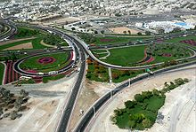

D 89 leading to Dubai Airport

The airport is connected by the road D 89. One of the longest intra-city roads, D 89 begins at the Deira Corniche and runs perpendicular to D 85 (Baniyas Road). From Deira, the road progresses south-eastward towards Dubai International Airport, intersecting with E 311 (Emirates Road) past the airport. A road tunnel underneath one of the runways was built in 2003.

### **Metro**

The airport is served by Dubai Metro, which operates two lines through or near the airport. The Red Line has a station at each of Terminal 3 and Terminal 1. Services run between 6 am and 11 pm every day except Friday, when they run between 1 pm and midnight. These timings differ during the Islamic holy month of Ramadan. The stations are located in front of both terminals and can be accessed directly from the arrivals areas.

The Green Line has at a station near the Airport Free Zone, from which passengers can connect to Terminal 2.

The Purple and Blue Lines are under construction and these two lines will also have a station.

### **Bus**

Dubai Buses operated by RTA run a number of routes to the city, but mainly Deira, and are available at the Airport Ground Transportation centre and the Arrivals at every terminal.

Passengers who need to transfer between Terminals 1 and 3, and Terminal 2 can use the inter-terminal shuttle bus service which operates frequently.

Bus stations are situated opposite both Terminal 1, 2 and 3. Local buses 4, 11, 15, 33 and 44 can be used to connect with Terminal 1 and 3, while bus 2 connects with Terminal 2. Dubai International Airport Buses provide air-conditioned transport into the city centre and over 80 hotels in the city.

Emirates offers a complimentary coach service, which operates three daily services to and from Al Ain, and four daily, to and from Abu Dhabi. So does Etihad.

### **Taxi**

The airport is served by the Government owned Dubai Taxi Agency, which provides 24-hour service at the arrivals in every terminal.

**2.9 SERVICES**

### **Aviation services**

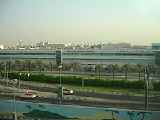

The Emirates Flight Catering centre, which was expanded in 2007, is capable of producing 115,000 meals per day.

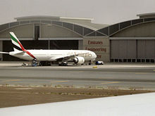

Emirates Engineering Centre aircraft hangars at DXB

#### **Ground handling**

Ground handling services at Dubai International Airport has been provided by Dnata Ground Handling Services.

Emirates Airlines has over 2000 Airport Services employees current serving the airport.

Services include cargo ramp and technical support services to airlines at Dubai Airport.

#### **Aircraft maintenance**

Emirates Engineering, based in Dubai, operates the aircraft maintenance and engine test cell technical facilities at the airport. Emirates Engineering currently provides full support for the Emirates Airline fleet and all the other international operations at the airport.

Current facilities include:

* Seven aircraft hangars all capable of handling the A380 (currently the largest aircraft hangar in the world)
* Aircraft painting hangar
* Aircraft processing plant
* Aircraft engine run-up facility enclosure
* Engineering Line Maintenance facility
* Engine Test Cell
* Aircraft spare parts stores

### **Passenger services**

The airport has over 26,000 m2 (280,000 sq ft) of retail space spread between its three main terminals and includes many shopping and eating outlets. The Dubai duty-free shopping area in Terminal 2 covers 1,400 m2 (15,000 sq ft) in departures and 50 m2 (540 sq ft) in arrivals. The 3,437-square-metre (37,000 sq ft) extension included a larger arrivals hall as well.

Extensive upgrading work on existing retail areas since 2004 in Terminals 1 and 2 has increased sales. Dubai Duty Free Company announced annual sales of Dhs5.9 billion (US$1.6 billion) in 2012, representing a 10 per cent increase on the previous year. In 2008, Dubai Duty Free doubled its retail space from 7,000 to 15,000 m2 (75,000 to 161,000 sq ft) with the inauguration of the new Emirates Terminal 3 in October 2008. Dubai Duty Free recorded more than 23.5 million transactions in 2012. As of August 2009, Dubai Duty Free was the biggest single airport retail operation in the world ahead of London's Heathrow and Seoul's Incheon airports.

In addition to a wide array of duty-free shops and eating outlets, Dubai Airport has two open-air garden areas. Dubai Airport has numerous business centres located around the airport. Within the international transit area of the interconnected Terminals 1 and 2, internet and games facilities, prayer rooms, showers, spas, gym, swimming pool and three hotels are provided. Various lounge areas are provided, some including children's play areas or televisions showing news, movies and sports channels. Terminal 3 has a left luggage facility operated by Emirates in the Arrivals area where layover passengers can leave their luggage for a fee while they go sightseeing.

## **Safety and security**

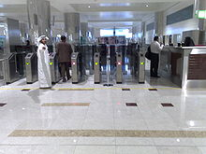

Smart Gate immigration counters at Passport Control

The Civil Aviation Authority of Dubai manages the overall safety and security of the airport. Pre-screening takes place in all terminals at the entrance of the airport. Iris scanning has been implemented in all UAE airports. This type of scanning prevents those deported from the UAE for serious criminal charges from returning again using fraudulent documents.

The airport uses highly sensitive equipment to conduct thorough searches on travellers into the UAE, including screening for smuggling, possessing or taking illegal drugs in the country. A senior Dubai judge was quoted on 11 February 2008, by *Seven Days* saying, "These laws help discourage anyone from carrying or using drugs. Even if the amount of illegal drugs found on someone is 0.05 grams, they will be found guilty. The penalty is a minimum four years if it is for personal use. The message is clear—drugs will not be tolerated". A number of travellers have been held pending charge while Dubai authorities test their possessions, blood and urine for any trace of contraband.

In 2018, Houthi rebel group claimed that Dubai airport had been attacked by drones launched by Houthi rebels from Yemen. In response, Dubai Airports stated “With regards to reports by questionable sources this morning, Dubai Airports can confirm that Dubai International (DXB) is operating as normal without any interruption”.

**2.10 10 FACTS ABOUT DUBAI AIRPORT**

Dubai International Airport is a major aviation hub not only in the UAE but also in the whole world. It’s not a secret that the city of Dubai is obsessed with luxe and wealth. So, its main entry point might not be an exception. Discover 10 interesting facts about Dubai Airport that you’ve never thought about before**.**

1. **Dubai International airport is the fastest-growing aviation hub in the world**

It even beats the world record holder Malaysia with more than 200,000 new seats each year. In 2017, more than 87 million passengers traveled through Dubai airport.

It provides modern infrastructure and services and manages connections between 260 destinations worldwide. It’s a transit zone for more than 100 airlines. Its terminals are equipped with modern facilities and the best lounges.

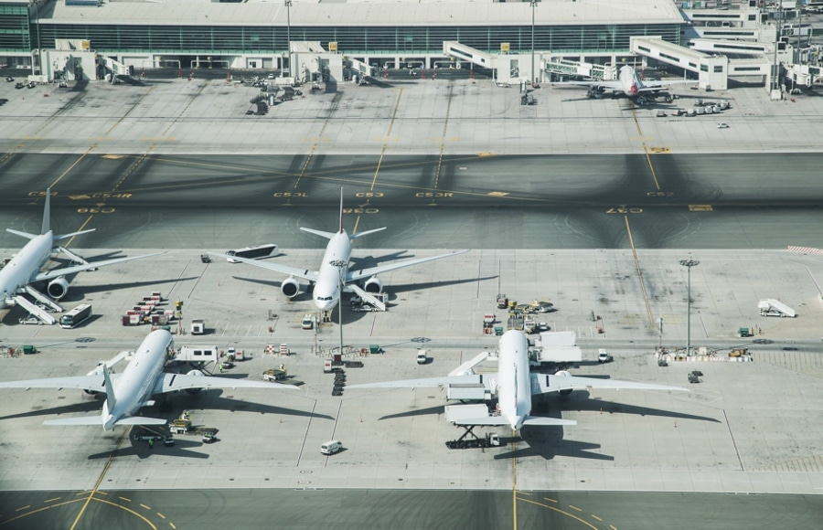

1. **DXB is the main hub for Emirates, Qantas, and FlyDubai airlines**

Emirates is considered as one of the best passenger airlines in the world. This is why its main hub should have the same level of service and facilities. Terminal 3 is entirely dedicated to these airlines for more comfort of their prestigious passengers.

The Emirates business class lounge is an entire world of entertainment. Besides countless information desks, there are airport staff members with “May I help you” T-shirts.

1. **The DXB Duty-free store is the biggest in the world**

Dubai is a worldwide **shopping capital**. Its airport is not deviating from this rule. The numerous Duty-free stores are situated in Terminals. This is a real empire of world-class shopping experience. So, it will certainly keep you busy while waiting for your connecting flight.

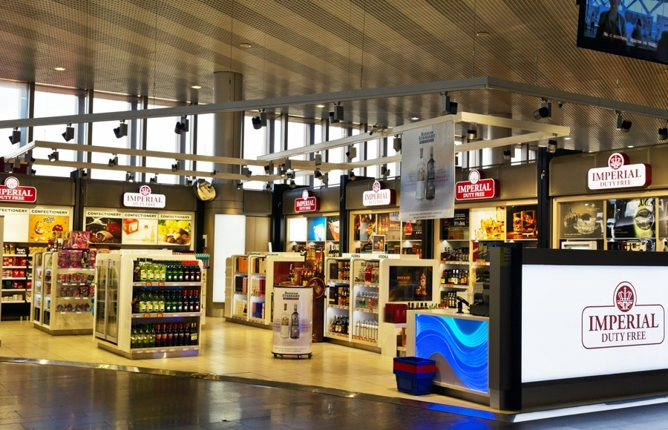

1. **The airport has its own five-star hotel inside its building**

If you are exhausted from your long flight, it’s time to get some rest in the **Dubai International hotel**. Luxury amenities are guaranteeв. It is situated in Terminal 1 and offers a swimming pool, restaurants, and a conference hall.

The structure also provides tiny rooms in its Snooze Cube hotel. It’s located in Terminal 1. For a small amount of money (16 dollars) you can have free wifi, shower and a few hours of sleep. And don’t worry to miss out your connecting flight. The staff will wake you up if needed.

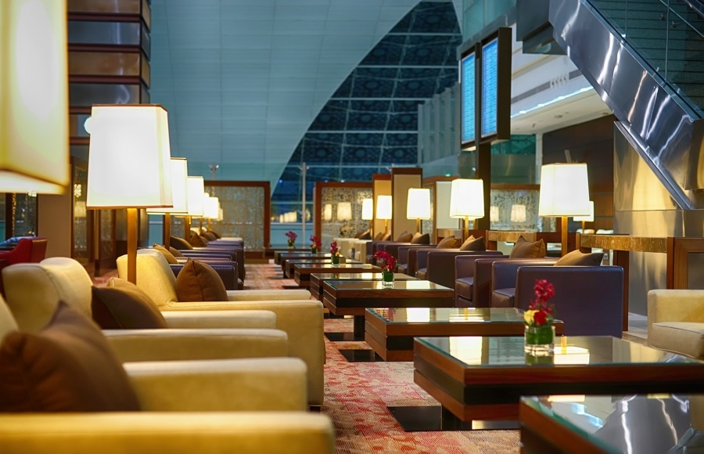

1. **The airport has its own Zen Gardens**

Gardens is located in Terminal 3 and it is a heaven to escape from the heavy noise of this busy airport. Get some rest and just relax in a natural environment before your connection flight. This is one of the most **interesting facts** about Dubai Airport you should not skip.

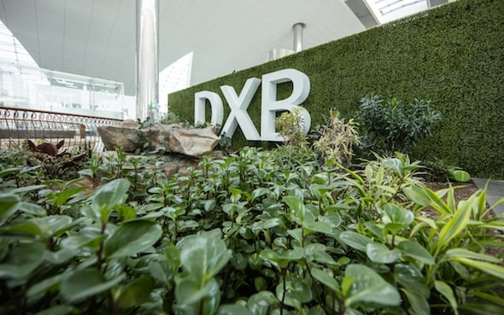

1. **The Dubai Airport is quite big to welcome the A380 aircrafts**

The Concourse A of Terminal 3 is dedicated to the giant **Airbus A380** aircraft. It opened in 2013 for this purpose. Imagine how big an airport might be to ensure the simultaneous boarding of more than 800 passengers.

The aircraft capacity forces to provide the best airport services to the clients. The airport uses underground trains and tunnels to connect the Concourse A to the other parts of the building.

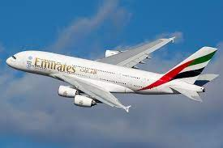

1. **The airport provides various entertainment facilities**

In standard airports, you would only find facilities to ensure your smooth flight. But Dubai Airport is an out-of-standard experience. There is an outdoor swimming pool, gym, natural gardens, cinemas, restaurants, and many other entertainment spots.

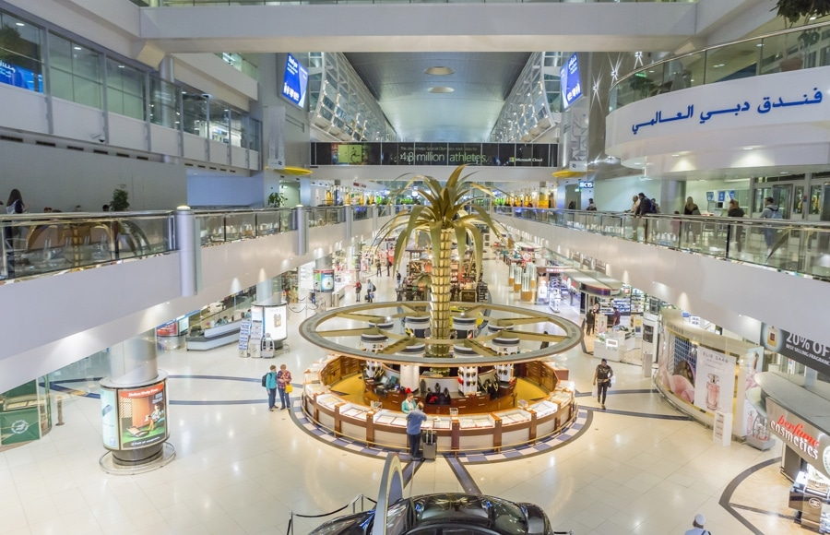

1. **The Dubai Airport wifi is the fastest in the world**

DXB took the comfort of its passengers to the next level. It has unlimited access to wifi. In addition, the wifi is the **fastest wifi** in comparison to other airports. You need to find “DXB Free WIFI” or “DWC Free WIFI” networks to get connected.

Otherwise, in a heavy air traffic period, access to the wifi can be limited. We recommend buying 30 AED (8 dollars) unlimited **daily pass** if you are here for an overnight.

1. **DXB currently employs more than 90,000 people**

Currently, the city ensures its development by tourism revenues. The main airport of Dubai employs more than 90,000 people. It’s the busiest airport in the world by international passenger traffic. This is also one of the busiest airports for cargo flights.

The city of Dubai believes it will become the largest airport in the world. By 2020, it will have a capacity of 160 million passengers and 12 million tonnes of cargo per year. This is certainly one of the most interesting facts about Dubai airport.

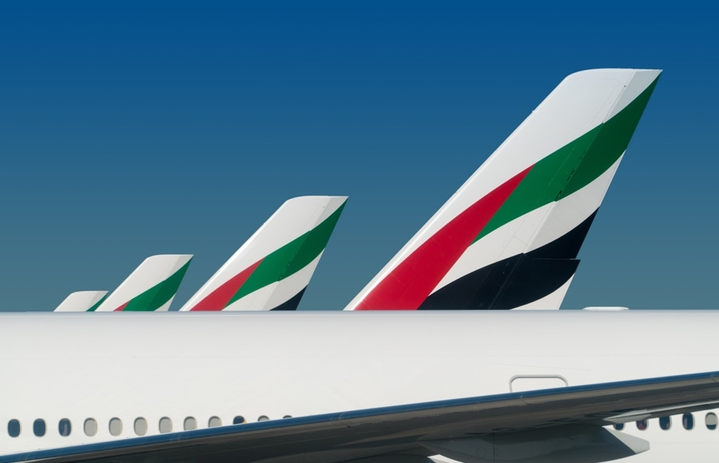

1. **There are smart gates in DXB**

Handling passenger traffic is one of the difficult tasks of any airport. Sometimes, it can become a huge problem due to delays, cancellations or heavy air traffic. Dubai could handle this problem like a boss.

The residents of the United Arab Emirates can pass through smart gates with their Emirates ID. In this way, they will skip queues without sacrificing valuable time. Don’t forget that time is money.

**2.11 SEE HOW DUBAI AIRPORT HANDLES INTERNATIONAL TOURISTS**

**AND PASSENGERS DURING COVID 19 PANDEMIC**

Dubai airports has all safety measures in place, from testing kits to isolation

1. **More tourists arrive at Dubai airport today. All passengers underwent thermal screening and those who did carry a negative Covid result were tested on site**

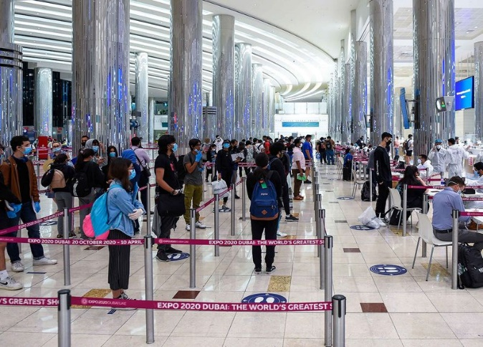

1. **A tourist receives instruction at Dubai airport.**

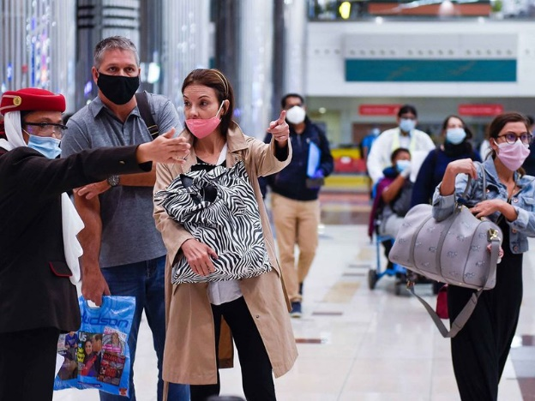

1. **Tourists wait in line to get a medical screening upon arrival at Dubai airport. Dubai has started to welcome visitors and tourists from July 7 while adhering to the highest standards of health and safety in line with international protocols.**

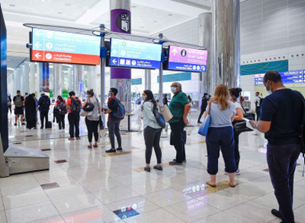

1. **An Emirati policeman directs a tourist to get a medical screening upon arrival at Dubai airport.**

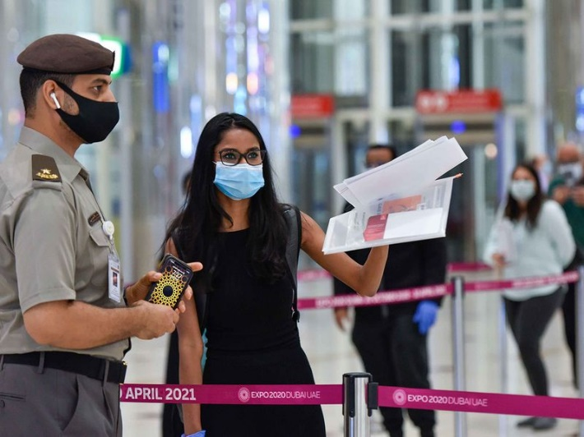

1. **Tourists wait in line to get a medical screening upon arrival at Dubai airport.**

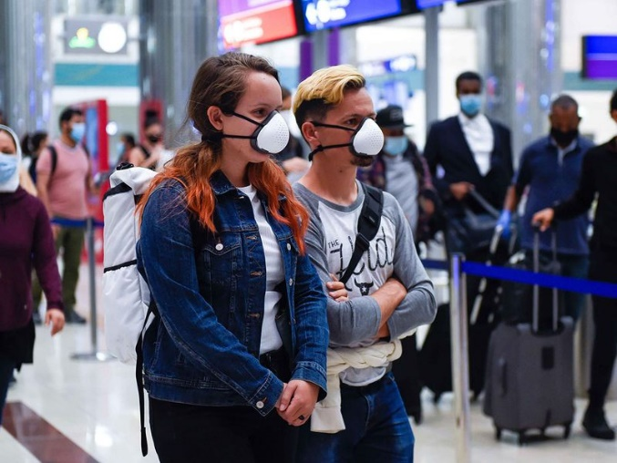

**6. A tourist takes a selfie before he gets a medical screening upon arrival at at**

**Dubai airport**

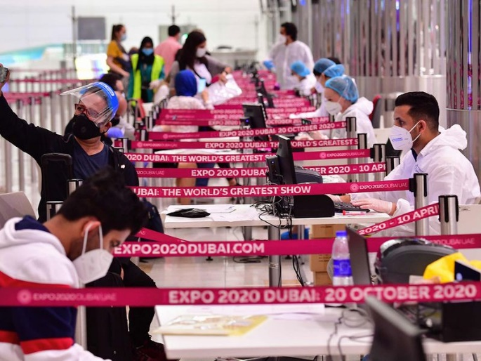

1. **Tourists wait in a que to get their papers processed upon arrival at Dubai airport. Dubai International adopts highest standards of health and safety**

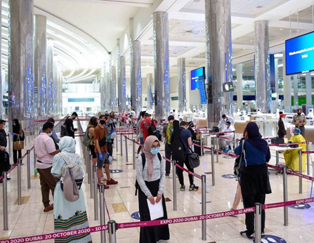

1. **Passengers get a medical screening upon arrival at Terminal 3 at Dubai airport.**

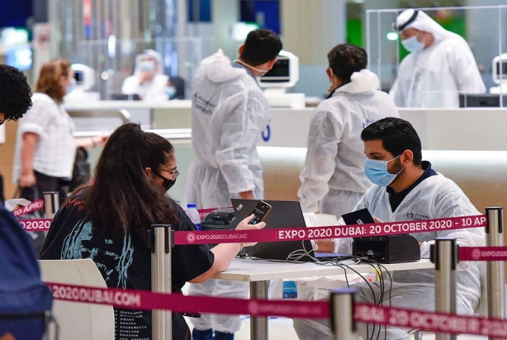

1. **A tourist gets her papers checked at the immigration desk upon arrival at Dubai airport.**

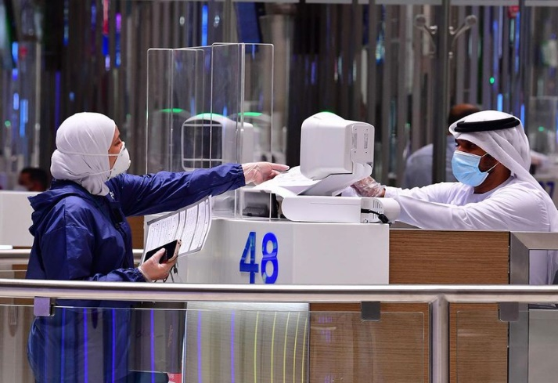

1. **Airline staffers wearing protective gear guides tourists to get a medical screening upon arrival at Teminal 3, Dubai airport.**

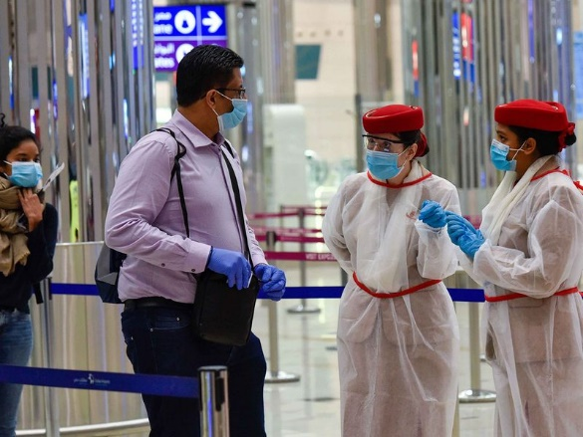

1. **Passenger check thier phones as they wait to get a medical screening upon arrival at Teminal 3 at Dubai airport.**

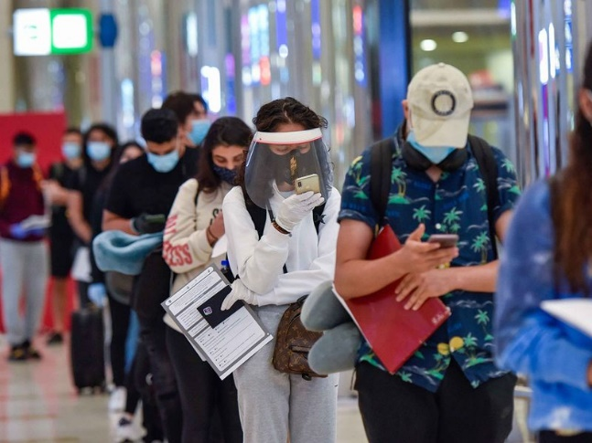

1. **A passenger buys a phone connection at the airport.**

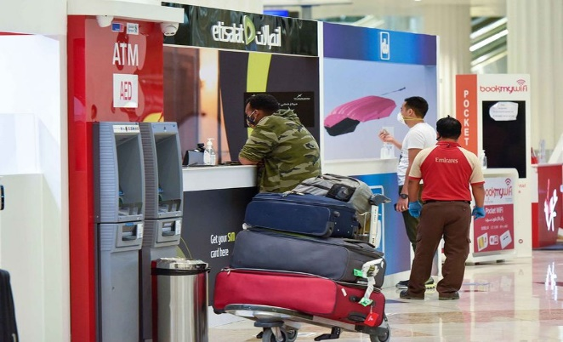

1. **A tourist waits for her luggage upon arrival at Dubai airport.**

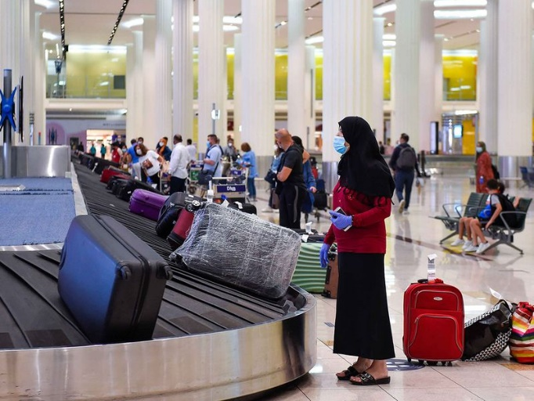

1. **A bride exits with her luggage after arrival to Teminal 3 at Dubai airport, as the city reopens to tourists after a long shutdown due to the COVID-19 pandemic**

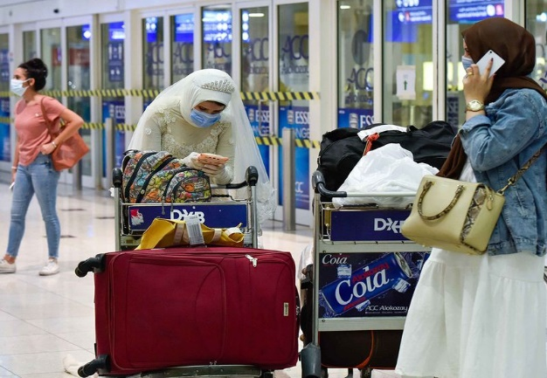

1. **Taxi drivers wait for customers outside Dubai airport.**

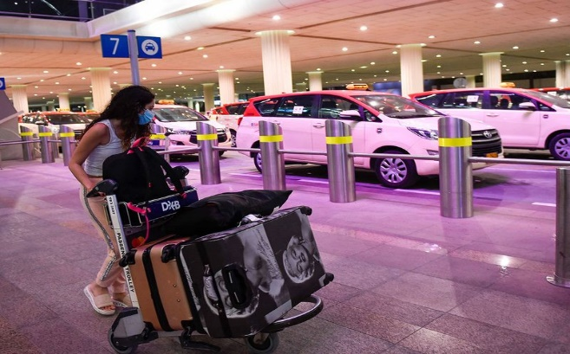

**2.12 DXB RECOGNISED AS THE BEST AIRPORT AT THE BUSSINESS**

**TRAVELLER ME AWARDS**

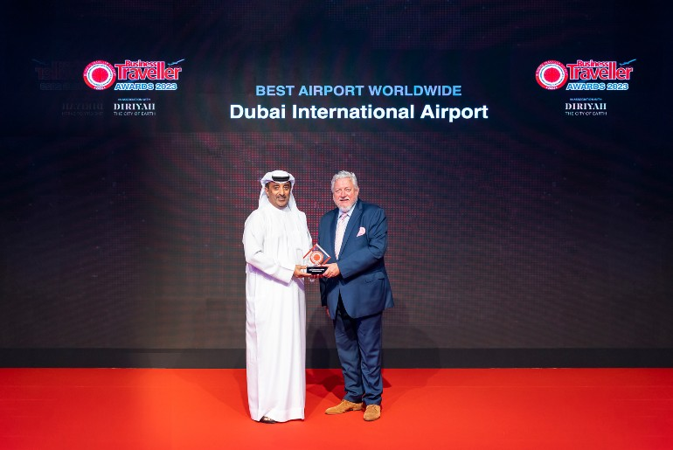

Dubai, UAE: Dubai International (DXB) was recognised as both the ‘Best Airport in the Middle East’ and ‘Best Airport Worldwide’ at the 22nd annual Business Traveller Middle East Awards, held at the Palazzo Versace Dubai on Monday (May 1).

The awards acknowledge DXB’s spectacular performance balancing high growth, which propelled the hub to retain its title as the world’s number one international airport for the 9th year running, while continuing to radically enhance the airport experience for 66 million passengers.

The Business Traveller Awards celebrates leaders in business travel and tourism, with brands recognised across the 40 hotly contested categories spanning three main divisions. The gala ceremony was attended by more than 250 dignitaries representing top brands and key players from the travel and tourism sectors. The awards are judged through a robust public voting system, comprised of feedback from frequent flyers and readers of the Business Traveller magazine.

H. E. Jamal Al Hai, Deputy CEO of Dubai Airports received the awards on behalf of DXB and Eugene Barry, EVP Commercial was in attendance at the ceremony.

**2.13 SUMMARY**

Dubai International Airport is the primary international airport serving the city of Dubai, United Arab Emirates (UAE). It is one of the busiest and most modern airports in the world, known for its state-of-the-art facilities and infrastructure.

Here are some key points about Dubai International Airport:

1.Location:

The airport is located in the Al Garhoud district, about 4.6 kilometers (2.9 miles) southeast of Dubai's city center.

2.Terminal Complex:

Dubai International Airport has three passenger terminals: Terminal 1, Terminal 2, and Terminal 3. Terminal 1 and Terminal 3 are used for international flights, while Terminal 2 is mainly for regional and low-cost carriers.

3.Terminal 1:

Terminal 1 is the oldest terminal at Dubai International Airport and has been expanded and renovated over the years. It handles many international airlines and offers a wide range of facilities including duty-free shops, restaurants, lounges, and immigration services.

4.Terminal 2:

Terminal 2 is a smaller terminal primarily used by regional carriers and low-cost airlines. It is less extensive in terms of facilities compared to Terminal 1 and Terminal 3.

5.Terminal 3:

Terminal 3 is the largest terminal and is dedicated to Emirates, the flagship carrier of Dubai. It is one of the largest airport terminals in the world and offers a luxurious experience with numerous shops, restaurants, lounges, and amenities.

6.Concourse:

Terminal 3 includes Concourse A, Concourse B, and Concourse C. Concourse A is the world's first and largest purpose-built facility for the Airbus A380, while Concourse B and C serve various airlines.

7.Facilities:

Dubai International Airport offers a wide range of facilities to enhance passenger experience, including duty-free shops, luxury boutiques, restaurants, cafes, lounges, prayer rooms, children's play areas, Wi-Fi access, currency exchange, banking services, and car rental counters.

8.Connecting Flights:

Dubai International Airport is a major hub for connecting flights, and its geographical location makes it an ideal transit point between Europe, Asia, and Africa.

9.Passenger Traffic:

Dubai International Airport consistently ranks among the world's busiest airports in terms of passenger traffic. It serves as the primary gateway for travelers visiting Dubai and connecting to other destinations.

9.Expansion Plans:

Dubai International Airport has undergone several expansion projects to accommodate the growing number of passengers. The airport authorities have also developed Dubai World Central (DWC), now known as Al Maktoum International Airport, to further expand aviation capacity in Dubai.

It's worth noting that airport information can change over time, so it's always a good idea to check for the most up-to-date information from official sources or the airport's website before planning a trip.

**2.14 REFERENCE**

Help from internet following websites links have been used in the completion of this project file**:**

* "Quantifying the Economic Impact of Aviation in Dubai". Archived from the original on 26 December 2014. Retrieved 15 January 2018.
* United Arab Emirates AIP Archived 30 December 2013 at the Wayback Machine
* "Preliminary 2012 World Airport Traffic and Rankings". Aci.aero. Archived from the original on 17 May 2013. Retrieved 29 March 2013.
* "OMDB: Dubai International Airport". SkyVector. 31 December 2020. Archived from the original on 27 February 2021. Retrieved 12 January 2021.
* "Dubai remains world's busiest international airport". Emirates 24/7. Dubai: Dubai Media Incorporated. 24 January 2017. Archived from the original on 5 November 2021. Retrieved 31 August 2017.
* "Year to date". Archived from the original on 13 August 2018. Retrieved 1 June 2015.
* "Year to date". Archived from the original on 25 December 2018. Retrieved 1 June 2015.
* "Where to spot your favourite aircraft type". anna.aero. 14 December 2016. Archived from the original on 22 October 2021. Retrieved 2 June 2017.
* "Fact sheets, Reports & Statistics". Dubaiairport.com. Archived from the original on 28 September 2013. Retrieved 4 July 2013.
* "Dubai Airport Terminal 2 installs 15,000 solar panels". gulfnews.com. 15 July 2019. Archived from the original on 27 July 2019. Retrieved 28 July 2019.
* Pereira, Nikhil. "Emirates passenger numbers grew 9% in 2015 - HotelierMiddleEast.com". Archived from the original on 19 April 2021. Retrieved 2 June 2017
* "Record month caps off record year at Dubai International". Archived from the original on 1 February 2014. Retrieved 1 June 2015.

Following books are used to have an idea about British Airways:

* John, Issac. "UAE carriers set to scale new heights". khaleejtimes.ae. Archived from the original on 26 December 2014. Retrieved 14 September 2017.
* Ellis, Dominic (8 October 2018). "Dubai International Airport to remain main hub for next 10 years". Gulf Business. Archived from the original on 16 February 2019. Retrieved 16 February 2019.
* Cornwell, Alexander; Arnold, Tom; Barbuscia, Davide (3 October 2018). "Dubai's $36 billion Al Maktoum airport expansion put on hold: sources". Reuters. Archived from the original on 16 February 2019. Retrieved 16 February 2019.
* Thome, Wolfgang H. (3 September 2008). "Move To Occur in Mid-October Emirates moving to new Terminal 3 in Dubai". eTurboNews.com. Archived from the original on 19 November 2008. Retrieved 16 July 2009.
* Sarah Cowell (9 June 2009). "Terminal 2 handed over to Flydubai | Supply Chain News". ArabianSupplyChain.com. Archived from the original on 7 July 2011. Retrieved 16 July 2009.
* Thomas Pallini 2020-11-04T17:35:56Z. "Israeli Airlines Rushing to Start UAE Flights As Relations Normalize". Businessinsider.com. Archived from the original on 8 November 2020. Retrieved 20 November 2021.
* Denman, Selina. "Cathay Pacific to resume flights between Dubai and Hong Kong". The National. Abu Dhabi. Archived from the original on 16 July 2022. Retrieved 16 July 2022.
* Kaminski-Morrow, David. "Emirates sets date to open daily Israeli services". Flight Global. London: DVV Media International Limited. Archived from the original on 16 March 2022. Retrieved 15 March 2022.
* Orban, André (17 September 2021). "Saudi Arabia's low-cost airline flyadeal receives initial trio of new A320neos". www.aviation24.be. Archived from the original on 23 September 2021. Retrieved 22 September 2021.
* Godinho, Varun (20 October 2021). "Flydubai to begin flights to Sohar in Oman". Gulf Business. Archived from the original on 20 October 2021. Retrieved 20 October 2021.
* Maceda, Cleofe (28 January 2019). "flydubai to launch first direct flights from Dubai to Tashkent". gulfnews.com. Al Nisr Publishing LLC. Archived from the original on 28 January 2019. Retrieved 28 January 2019.
* Liu, Jim (4 December 2017). "flydubai adds new destinations in S18". Routesonline. Archived from the original on 5 December 2017. Retrieved 4 December 2007.